**SYSTEMS ENGINEERING PLAN (SEP)**

**OUTLINE**

**20 April 2011**

**Version 1.0, 04/20/2011**

**MANDATED FORMAT FOR ALL  
SYSTEMS ENGINEERING PLANS**

**PROGRAM NAME – ACAT LEVEL**

**SYSTEMS ENGINEERING PLAN**

**VERSION ___**

**SUPPORTING MILESTONE _**

**AND**

***[APPROPRIATE PHASE NAME]***

***[DATE]***

**\*\*\*\*\*\*\*\*\*\*\*\*\*\*\*\*\*\*\*\*\*\*\*\*\*\*\*\*\*\*\*\*\*\*\*\*\*\*\*\*\*\*\*\*\*\*\*\*\*\*\*\*\*\*\*\*\*\*\*\*\*\*\*\*\*\*\*\*\*\*\*\*\*\*\*\*\*\*\*\*\*\*\*\*\***

**OFFICE OF THE SECRETARY OF DEFENSE (OSD) APPROVAL**

_______________________________________________ _________________________

Date

Deputy Assistant Secretary of Defense

Systems Engineering

(for MDAPs and MAIS Programs)

[or designated SEP approval authority]

SUBMITTED BY

|  |  |  |  |
| --- | --- | --- | --- |
| __________________________  Name  Program Lead Systems Engineer | __________  Date | __________________________  Name  Program Manager | _________  Date |

concurrence

|  |  |  |  |
| --- | --- | --- | --- |
| __________________________  Name  Lead/Chief Systems Engineer  (Program Executive Office, System Center or Command) | __________  Date | __________________________  Name  Program Executive Officer or Equivalent | _________  Date |

component approval

|  |  |
| --- | --- |
| __________________________  Name  Title, Office  Component SEP Approval  Authority | __________  Date |

**Table of Contents**

1. Introduction – Purpose and Update Plan
2. Program Technical Requirements
   1. Architectures and Interface Control
   2. Technical Certifications
3. Engineering Resources and Management
   1. Technical Schedule and Schedule Risk Assessment
   2. Engineering Resources and Cost/Schedule Reporting
   3. Engineering and Integration Risk Management
   4. Technical Organization
   5. Relationships with External Technical Organizations
   6. Technical Performance Measures and Metrics
4. Technical Activities and Products
   1. Results of Previous Phase SE Activities
   2. Planned SE Activities for the Next Phase
   3. Requirements Development and Change Process
   4. Technical Reviews
   5. Configuration and Change Management Process
   6. Design Considerations
   7. Engineering Tools

Annex A – Acronyms

NOTE: All sections above are driven by Section 139b of title 10 United States Code and DoDI 5000.02 policy; additional content is optional at the discretion of the Component.

**Tables and Figures**

(Mandated are listed below)

**Tables**

Table 1.1-1 SEP Update Record

Table 2.1-1 Required Memoranda of Agreement

Table 2.2-1 Certification Requirements

Table 3.4.4-2 IPT Team Details

Table 3.6-2 Technical Performance Measures and Metrics

Table 4.4-1-n Technical Review Details

Table 4.6-1 Design Considerations

Table 4.6-2 R&M Activity Planning and Timing

Table 4.7-1 Engineering Tools

**Figures**

Figure 3.1-1 System Technical Schedule

Figure 3.3-1 Technical Risk Cube

Figure 3.4.1-1 Program Office Organization

Figure 3.4.2-1 Program Technical Staffing

Figure 3.4.3-1 Contractor Program Office Organization

Figure 3.4.3-2 Contractor Technical Staffing

Figure 3.4.4-1 IPT/WG Team Hierarchy

Figure 3.6-1 Reliability Growth Curve

Figure 4.3.1-1Requirements Decomposition/Specification Tree/Baselines

Figure 4.5-1 Configuration Management Process

(Additional, non-mandatory tables and figures may be included at the Component’s direction or the PM’s discretion.)

1. Introduction – Purpose and Update Plan

* Who will use the Systems Engineering Plan (SEP)?
* What is the plan to align Prime Contractor’s Systems Engineering Management Plan (SEMP) with the Program Management Office (PMO) SEP?
* Summarize how the SEP will be updated and the criteria for doing so to include:
  + Timing of SEP updates (e.g., following a conducted technical review, prior to milestones, as a result of SE planning changes, as a result of specific contractor-provided inputs),
  + Updating authority, and
  + Approval authorities for different types of updates.
* Expectations:

SEP should be a “living” “go to” technical planning document and the blueprint for the conduct, management, and control of the technical aspects of the government’s program from concept to disposal. SE planning should be kept current throughout the acquisition lifecycle.

SEP is consistent with other program documentation.

SEP defines the methods for implementing all system requirements having technical content, technical staffing, and technical management.

Milestone Decision Authority (MDA)- approved SEP provides authority and empowers the Lead SE (LSE)/Chief Engineer to execute the program’s technical planning.

SE planning is kept current throughout acquisition lifecycle. For ACAT I programs, OSD/ Directorate Systems Engineering (DSE) expects to approve SEP updates to support milestone reviews (e.g., Milestone (MS) A, B, and C) and program restructures; the PEO can approve SEP updates to support SE technical reviews and program changes that impact the technical strategy.

Tailoring for Technology Development (TD) and Engineering and Manufacturing Development (EMD) phases: SEP should be updated after contractor award to reflect winning contractor(s)’ technical strategy reflected in SEMP.

|  |  |  |  |
| --- | --- | --- | --- |
| Revision Number | Date | Log of Changes Made and Description of Reason Changes | Approved By |
| 0.7 | April 2008 | Addressed Lead Systems Engineer’s (LSE’s) concerns – see comments in separate file | LSE |
| 0.8 | June 2008 | Updated Section 1 with draft requirements  Added Section 4, Design Verification section | LSE |
| 0.9 | October 2008 | Addressed SE WIPT (to include Service and OSD) comments – many changes – see Comment Resolution Matrix (CRM) | LSE |
| Etc. |  |  |  |

Table 1.1-1 SEP Update Record (mandated) (sample)

1. Program Technical Requirements
   1. **Architectures and Interface Control** – List the architecture products that will be developed, to include system level physical and software architectures and DODAF architectures. Summarize the approach for architecture development to include:

Program’s DODAF architecture development efforts.

A system physical architecture diagram (delineating physical interfaces), if available.

A system functional architecture diagram (delineating functional interfaces), if available.

How software architecture priorities will be developed and documented.

How architecture products are related to requirements definition.

How engineering and architecture activities are linked.

|  |  |  |  |  |
| --- | --- | --- | --- | --- |
| **REQUIRED MEMORANDA OF AGREEMENT** | | | | |
| **Interface** | **Cooperating Agency** | **Interface Control Authority** | **Required By Date** | **Impact if Not Completed** |
|  |  |  |  |  |
|  |  |  |  |  |
|  |  |  |  |  |

Table 2.1-1 Required Memoranda of Agreement (mandated) (sample)

* Expectations: Programs whose system has external interfaces need to have dependencies (i.e., hierarchy) clearly defined. This should include interface control specifications, which should be confirmed early on and placed under strict configuration control. Compatibility with other interfacing systems and common architectures should be maintained throughout the development/design process.
  1. **Technical Certifications** - Summarize in the following table format the system-level technical certifications which must be obtained during program’s life-cycle.

|  |  |  |  |  |
| --- | --- | --- | --- | --- |
| **Certification** | **PMO Team/PoC** | **Activities to Obtain Certification1** | **Certification**  **Authority** | **Expected Certification Date** |
| Airworthiness | Airframe IPT |  |  | ?Q FY? |
| Clinger Cohen |  | Confirm compliance | Component CIO (MDAP/MAIS also by DoD CIO) | ?Q FY? |
| Transportability |  |  |  | ?Q FY? |
| Insensitive Munitions | Manufacturing WG | Reference Document: *PEO IM Strategic Plan* |  | ?Q FY? |
| Etc. |  |  |  | ?Q FY? |

Table 2.2-1 Certification Requirements (mandated) (sample)

1 This entry should be specific such as a specification compliance matrix; test, inspection, or analysis, or a combination. It can also reference a document for more information such as the TEMP.

* Expectations: Programs plan required technical certification activities and timing into the program IMP and IMS.

1. Engineering Resources and Management
   1. **Technical Schedule and Schedule Risk Assessment**

Who is responsible for technical schedule planning and execution?

How are program tasks identified and managed?

List scheduling/planning assumptions.

Identify which program office position/team is responsible for keeping the schedule up-to-date.

Figure 3.1-1 System Technical Schedule (mandated) (notional sample) *Note: Include an “as-of” date – time sensitive figure.*

**Technical Schedule** - Provide a detailed, integrated, life-cycle system schedule (see Figure 3.1-1) (with particular emphasis on the next acquisition phase) to include:

**Planned milestones**

Planned significant activities (viz., activities which must be performed in order to produce the system):

|  |  |
| --- | --- |
| * SE technical reviews * Technology on/off –ramps * RFP release dates * Software releases * Hardware (HW)/Software (SW) Integration events * Contract award (including bridge contracts) * Testing events/phases * System-level certifications | * Key developmental, operational, integrated testing * Technology Readiness Assessments (TRAs) * Logistics/sustainment events * Long-lead or advanced procurements * Technology development efforts to include competitive prototyping * Production lot/phases |

* Expectations: Programs should properly phase activities and key events (e.g., competitive prototyping, TRA, CDRs, etc.) to ensure a strong basis for making financial commitments. Program schedules are event driven and reflect adequate time for systems engineering (SE), integration, test, corrective actions and contingencies.

**Schedule Risk Assessment** - Summarize the program’s schedule risk assessment (SRA) process and its results to include:

What SRA techniques will be used to determine program schedule risk (e.g., critical path analysis, Monte Carlo simulations, etc.).

Inherent impact of schedule constraints and dependencies and actions taken or planned to mitigate schedule drivers.

Results of any SRAs accomplished.

List significant critical path or likely critical path events/activities and any planned actions to reduce risk for each.

* Expectation: Programs should use SRAs to inform source selection and milestones, in addition to technical reviews.
  1. **Engineering Resources and Cost/Schedule Reporting** – List and summarize the program oversight and management systems that will integrate cost, schedule, and technical performance goals, metrics, and resources. Specifically address:

Work Breakdown Structure (WBS)

Summarize the relationship among the WBS, product structure, and schedule.

Identify the stakeholders who will develop the WBS.

Explain the traceability between the system’s technical requirements and WBS.

Integrated Master Plan (IMP)/ Integrated Master Schedule (IMS)

What is the relationship of the program’s IMP to the contractor(s) IMS; how are they linked/interfaced; and what are their primary data elements?

Who or what team (e.g., IPT/WG) is responsible for developing the IMP; when is it required; will it be a part of the RFP?

If used, how will the program use EVM cost reporting to track/monitor the status of IMS execution?

* Expectations:

Program should have an adequate IMP and IMS and requires the same from its contractor(s). The IMP and IMS clearly communicate the expectations of the program team, and provide traceability to the management and execution of the program by IPTs. They also provide traceability to the WBS, the Contract WBS (CWBS), the Statement of Work (SOW), systems engineering, and risk management, which together define the products and key processes associated with program success.

Programs should require offerors to provide a tight linkage across IMP, IMS, risk mitigation, WBS, and cost in their proposals and with EVMS when implemented.

Program events, accomplishments, and criteria defined in the government’s IMP/program schedule, when combined with offeror-proposed events, should define top-level structure of IMS for execution.

In the RFP, offerors should be directed to:

Add key tasks only to the level necessary to define and sequence work, identify dependencies, document risk mitigations and deliverables, and support cost estimation and basis of estimate (BOE) preparation.

Include cross linkage to the IMP in the offeror’s IMS, WBS/BOE, and risk mitigation steps.

Incorporate additional detailed planning as part of the program kickoff and Integrated Baseline Review (IBR) process.

* 1. **Engineering and Integration Risk Management**

**Risk Management Process Diagram** – Diagram the process for how the program plans to manage engineering and integration risk and how these processes will be integrated with the contractor(s). This should include how the PMO will identify and analyze risks; and plan for, implement (including funding), and track risk mitigation.

**Roles, Responsibilities, and Authorities**

Indicate roles, responsibilities, and authorities within the risk management process for:

* + - Reporting/identifying risks
    - Criteria used to determine if a “risk” submitted for consideration will become a risk or not (typically, criteria for probability and consequence)
    - Adding/modifying risks
    - Changing likelihood and consequence of a risk
    - Closing/retiring a risk

If Risk Review Boards or Risk Management Boards are part of the process, indicate who are the chair and participants and how often they meet.

List the risk tool(s) the program (program office and contractor(s)) will use to perform risk management in Table 4.7-1.

If program office and contractor(s) use different risk tools, how will the information be transferred across them? NOTE: In general, the same tool should be used. If the contractor’s tool is acceptable, then this merely requires Government direct, networked access to that tool.

**Technical Risks and Mitigation Planning** – Provide a risk cube (see Figure 3.3-1) or a listing of the current system-level technical risks with:

As-of date

Risk rating

Description

Driver

Mitigation status

* Expectations: Programs commonly use hierarchal boards to address risks and have integrated risk systems with their contractors, and their approach to identify risks is both top-down and bottoms-up. Risks related to technology maturation, integration, and each design consideration indicated in Table 4.6-1 should be considered in risk identification process.

Figure 3.3-1 Risk Cube (mandated) (sample)

*Note: Include an as-of date – time sensitive figure*

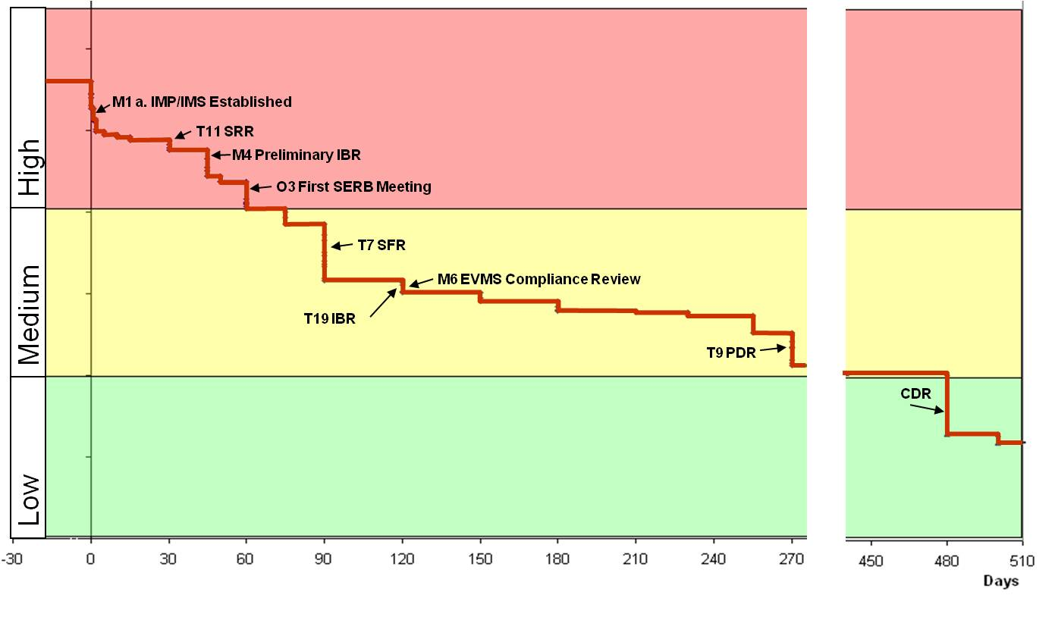

Figure 3.3-2 Risk Burn-down Plan (optional) (sample)

*Note: Include an as-of date – time sensitive figure*

* 1. **Technical Organization**
     1. **Government Program Office Organization** - Provide planned program office organization structure (i.e., wiring diagram to illustrate hierarchy) with an as-of date and include the following elements:

|  |  |
| --- | --- |
| * Legend, as applicable (e.g., color-coding) * Organization to which the program office reports * Program Manager (PM) * Lead/Chief Systems Engineer (LSE/CSE) | * Functional Leads (e.g., T&E, logistics, risk, reliability, software) * Core, matrix, and contractor support personnel * Field or additional Service representatives |

**PEO**

**PM**

**Business**

**Mgmt**

**Lead**

**Financial**

**Mgmt**

**Lead**

**Logistics**

**Mgmt**

**Lead**

**Tech**

**Lead**

**Test**

**Mgmt**

**Lead**

**Office**

**of the**

**Director**

**Program**

**Analysts**

**(2)**

**Procure**

**Analysts**

**(2)**

**Cost**

**Analyst**

**Cost**

**Analyst**

**Cost**

**Analyst**

**Procure**

**Analyst**

**Logistics**

**Mgmt**

**Analysts**

**(2)**

**Logistics**

**Mgmt**

**Analyst**

**SE Lead**

**Platform**

**Lead**

**Mission**

**Equip.**

**Lead**

**Weapons**

**Lead**

**Tester**

**Oper’l**

**Tester**

**DT&E**

**Engineer**

**Load**

**Master**

**Program**

**Integratr**

**Schedulr**

**Program**

**Analysts**

**(3)**

**SE**

**CM**

**Production**

**Engineer**

**Safety**

**Engineer**

**Certif.**

**Engineer**

**(2)**

**Interop. &**

**IA**

**Engineer**

**SW**

**Engineer**

**Weapons**

**Engineer**

**Field Team**

**Gov’t Core Team**

**Collocated Matrix**

**Contractor**

**Non-Collocated Matrix**

Figure 3.4.1-1: Program Office Organization (mandated) (sample)

*Note: Include an as-of date – time sensitive figure*

* + 1. **Program Office Technical Staffing Levels** – Summarize the program’s technical staffing plan to include:

Process and tools program will use to determine required technical staffing;

Risks and increased demands on existing resources if staffing requirements are not met;

A figure (e.g., sand chart) to show the number of required full-time equivalent (FTE) positions (e.g., organic, matrix support, and contractor) by key program events (e.g., milestones and technical reviews).

* Expectation: Programs should use a workload analysis tool to determine adequate level of staffing, appropriate skill mix, and required amount of experience to properly staff, manage, and execute successfully.

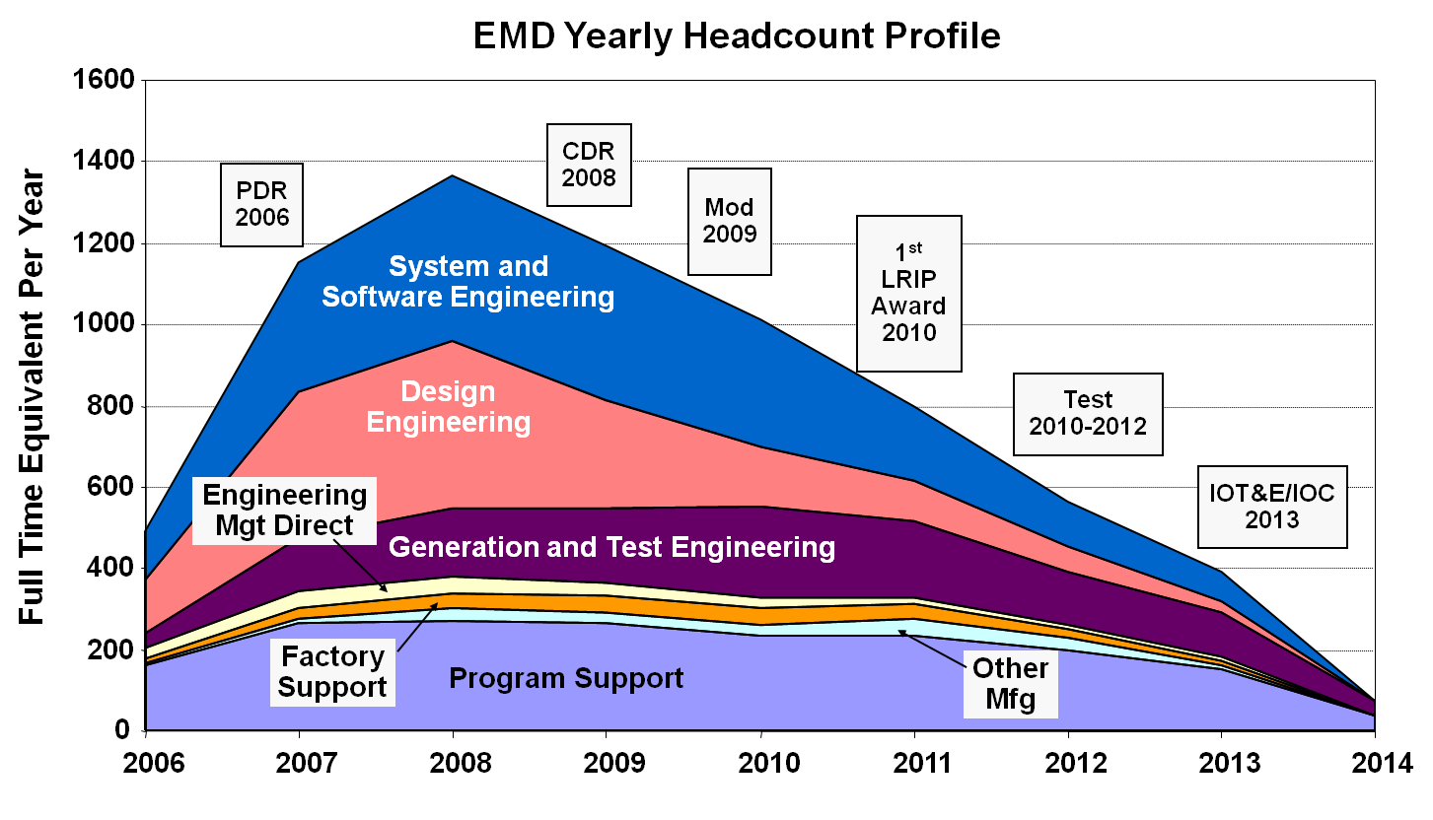

Figure 3.4.2-1 Program Technical Staffing (mandated) (sample)

* + 1. **Contractor(s) Program Office Organization** – When available, provide diagrams of the contractor(s) program office organization and staffing plans in figures analogous to Figures 3.4.1-1 and 3.4.2-1.
    2. **Engineering Team Organization and Staffing**

**Integrated Product Team (IPT) Organization** – Provide diagrams that show the ALL Government and contractors (when available) IPTs and their associated Working IPTs and Working Groups interrelated vertically and horizontally and that illustrate the hierarchy and relationship among them (see Figure 3.4.4-1). Identify the Government and contractor(s)’ leadership for all teams.

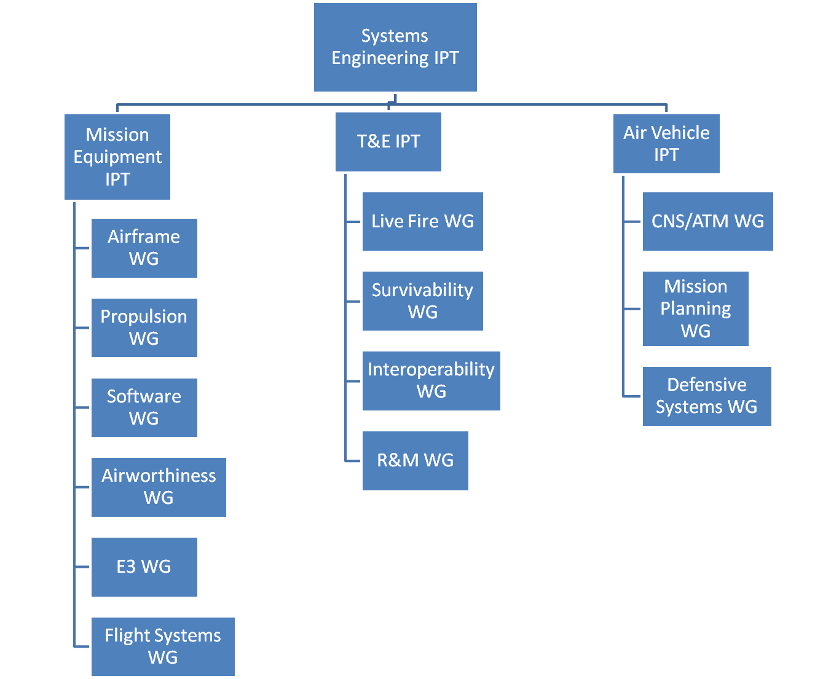

Figure 3.4.4-1 IPT/WG Team Hierarchy (mandated) (sample)

**IPT Details** – For ALL Government and contractor(s) (when available) IPTs and other key teams (e.g., Level 1 and 2 IPTS and WGs), include the following details either by attaching approved charters or as a table as seen below, Table 3.4.4-2:

|  |  |
| --- | --- |
| * IPT name * Chairperson position and name * Functional team membership (to include all design consideration areas from Section 4.6) | * IPT roles, responsibilities, and authorities * IPT processes * IPT products (e.g., updated baselines, risks, etc.) * IPT-specific metrics |

*Note: Make sure that the IPTs in the figure above match the IPTs in the table below!*

* Expectation: Program personnel should integrate SE activities with all appropriate functional and stakeholder organizations. In addition, IPTs should include personnel responsible for each of the design consideration areas in Section 4.6, Table 4.6-1.

|  |  |  |  |  |
| --- | --- | --- | --- | --- |
| **Team**  **Name** | **Chairperson** | **Team Membership**  **(by Function or Organization)** | **Team Role, Responsibility, and Authority** | **Products and Metrics** |
| **SE IPT** | Lead SE | * Program Office   + Platform Lead   + Mission Equipment Lead   + Weapons Lead   + Test Manager   + Logistics Manager   + SW Lead   + Production/Quality Manager   + Safety Lead   + Interoperability Rep.   + R&M Lead * PEO and PM * Service Representative * OSD SE * Key Subcontractor or Suppliers | Role: IPT Purpose  Responsibilities: Integrate all technical efforts   * Team Member Responsibilities * Cost, Performance, Schedule Goals * Scope, Boundaries of IPT Responsibilities   Schedule and frequency of meetings  Date of signed IPT charter and signatory | Products:  SEP/SEP Updates  IMP/IMS Input  Specifications  Metrics:  -Cost  -Performance  -Schedule |
| **XXX**  **IPT** | XXX Lead | * Program Office   + Lead SE   + Mission Equipment Lead   + Weapons Lead   + Test Manager   + Logistics Manager   + SW Lead   + R&M Lead   + Production/Quality Manager   + Safety Lead   + Interoperability Rep.   Key Subcontractor or Suppliers | Role: IPT Purpose  Responsibilities: Integrate all technical efforts   * Team Member Responsibilities * Cost, Performance, Schedule Goals * Scope, Boundaries of IPT Responsibilities   Schedule and frequency of meetings  Date of signed IPT charter and signatory | Products:  Specification input  SEP input  TES/TEMP input  AS input  Metrics:  Technical Performance Measure (TPM) 1  TPM 2 |

Table 3.4.4-2 IPT Team Details (mandated unless charters are submitted) (sample)

**IPT Alignment** – Briefly summarize how the Government teams relate to/interact with the Prime Contractor’s teams, if they are not the same teams.

* Expectation: Programs should shift IPT focus depending on the acquisition phase.

Tailoring for the Production and Deployment Phase: Describe how the organizational structure evolves after MS C. If the program doesn’t have a Production IPT during EMD Phase, one should be established in the P&D Phase.

* 1. **Relationships with External Technical Organizations** – What processes or methods will be used to document, facilitate, and manage interaction among SE team(s), external-to-program government organizations (e.g., FoS/SoS and contractor(s)/ competing contractor(s)) on technical tasks, activities, and responsibilities (e.g., requirements, technical baselines, and technical reviews) down to and including subcontractors.

**Responsible Organization and Authority** - Identify the organization responsible for coordinating SE and integration efforts associated with the FoS/SoS and its authority to reallocate resources (funding and manpower).

**Management** – Summarize how FoS/SoS interfaces will be managed to include:

Resolution of issues that cross PM, PEO, and Component lines;

Interface Control Documents (ICDs) and any interface control WGs (ICWGs);

Memorandums-of-Agreement (MOAs);

“Triggers” that require a FoS/SoS member to inform the others if there is a cost, schedule, or performance deviation;

Planned linkage between hardware and software upgrade programs within the FoS/SoS;

Any required Government Furnished Equipment/Property/Government Furnished Information (GFE/GFP/GFI) (e.g., test ranges, integration laboratories, and special equipment).

**Schedule** - Include a schedule (optional) which shows FoS/SoS dependencies such as alignment of technical reviews, major milestones, test phases, GFE/GFP/GFI, etc.

* Expectations: Programs should:

Recognize the importance of managing both the internal program schedule while maintaining synchronization with external programs’ schedules.

Develop MOAs with interfacing organizations that include:

Tripwires and notification to FoS/SoS members of any significant (nominally > 10%) variance in cost, schedule, or performance;

Mechanisms for FoS/SoS members to comment on any proposed interface changes; and

Fast-track issue identification and resolution process.

Develop a synchronized program schedule with interfacing programs schedules to provide insight into the potential impact of interfacing program schedule changes to include milestones, technical reviews, test periods.

Inform Component and OSD staffs so they better understand synchronizing funding and aligning priorities with external programs.

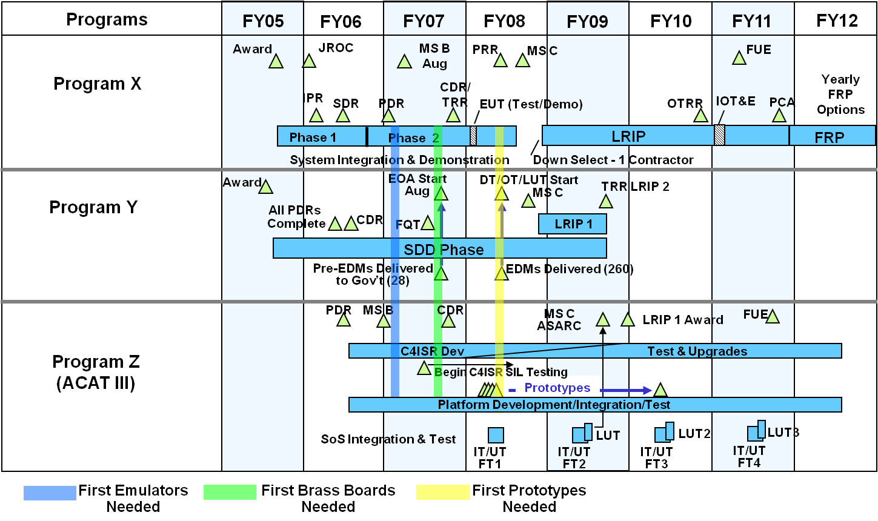

Figure 3.5-1 System-of-Systems Schedule (optional) (sample)

Note: Include an as-of date – time sensitive figure

* 1. **Technical Performance Measures and Metrics** – What is the program’s strategy for identifying, prioritizing, and selecting the set of metrics for monitoring and tracking program SE activities and performance? This explanation should include:

An overview of the measurement planning and metrics selection process, including the approach to monitor execution to the established plan, and identification of roles, responsibilities, and authorities for this process.

A minimum set of technical performance measures (TPMs) and intermediate goals and the plan to achieve them with as-of dates (to provide quantitative insight into requirements stability and specification compliance). Examples include TPMs in the areas of software, reliability, manufacturing, and integration to assess “execution to plan.”

For reliability, PMs shall use a growth curve to plan, illustrate, and report progress. Growth curves will be stated in a series of intermediate goals and tracked through fully integrated, system-level test and evaluation events until the reliability threshold is achieved, see Figure 3.6-1. If a single curve is not adequate to describe overall system reliability, provide curves for critical subsystems with rationale for their selection.

*Note: For ACAT I programs, performance-to-plan will be checked during Program Support Reviews (PSRs).*

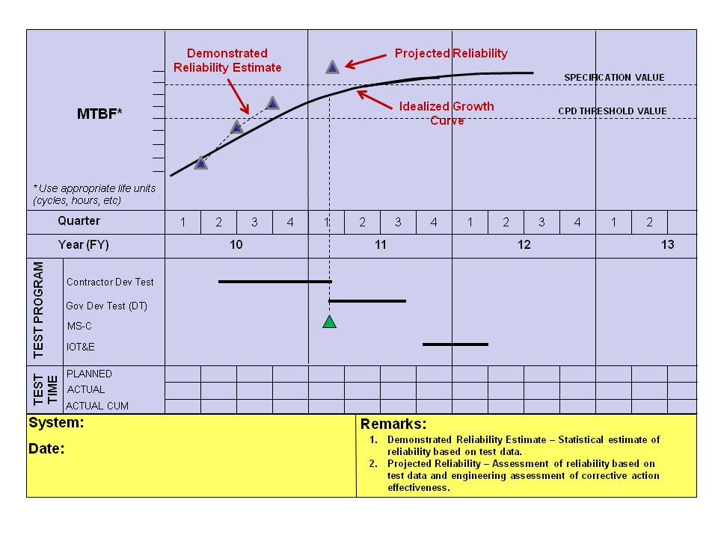

Figure 3.6-1 Reliability Growth Curve (mandated) (sample)

* Expectation: Programs should understand the amount of testing, test schedule and resources available for achieving the specification requirement. Programs should consider the following:

***Develop the growth planning curve as a function of appropriate life units (hours, cycles, etc,) to grow to the specification value.***

***How the starting point that represents the initial value of reliability for the system was determined.***

***How the rate of growth was determined. Rigorous test programs which foster the discovery of failures, coupled with management-supported analysis and timely corrective action, will result in a faster growth rate. The rate of growth should be tied to realistic management metrics governing the fraction of initial failure rate to be addressed by corrective actions along with the effectiveness of the corrective action.***

***Describe the growth tracking and projection methodology that will be used to monitor reliability growth during system-level test (e.g., AMSAA-Crowe Extended, AMPM).***

|  |  |  |  |  |  |  |  |  |
| --- | --- | --- | --- | --- | --- | --- | --- | --- |
| **Name** | **Responsible Position/IPT** | **KPP or KSA** | **Performance Spec.** | **PDR Status**  **Actual** | **MS B Status**  **Actual** | **CDR Status**  **Actual** | **MS C Status**  **Planned** | **FRP Status**  **Planned** |
| **Aerodynamic Drag (count)** | SE IPT |  | <222 | 225 | 223 | 220 | 187 | 187 |
| **Thermal Utilization (kW)** | SE IPT |  | <60 | 56 | 59 | 55 | 51 | 50 |
| **Electrical Power Usage (kW)** | SE IPT |  | <201 | 150 | 185 | 123 | 123 | 123 |
| **Operating Weight (lb)** | SE IPT |  | <99,000 | 97,001 | 101,001 | 97,001 | 85,540 | 85,650 |
| **Range (nm)** | SE IPT |  | >1,000 | 1,111 | 1,101 | 1,111 | 1,122 | 1,130 |
| **Average Flyaway Unit Cost (number)** | SE IPT |  | <1.5 | 1.3 | 1.58 | 1.37 | 1.35 | 1.32 |

*Note: Margin is 10%

Table 3.6-2 TPMs (mandated) (sample)

* Expectation: Programs will use metrics to measure progress.

1. Technical Activities and Products
   1. **Results of Previous Phase SE Activities** - Summarize (consider a tabular format) system-level technical reviews, trade studies, and independent reviews conducted to date; date(s) conducted; and key results or impact(s) to design and any related recommendations and status of actions taken. For MDAPs, these reviews shall include an assessment of manufacturing risk and readiness.
   2. **Planned SE Activities for the Next Phase** – Summarize key planned system engineering, integration, and verification processes and activities established or modified since the previous acquisition phase, including updated risk reduction and mitigation strategies and technical and manufacturing maturity.
   3. **Requirements Development and Change Process**
      1. **Analysis and Decomposition** – How will top-level requirements (i.e., from AoA, KPPs, KSAs, statutory, regulatory, certification, safety, software, hardware, etc.) be traced from the source JCIDS documents down to configuration item (CI) build-to specifications and Verification and Validation (V&V) plans?

Identify which program office position or team (e.g., IPT/WG) is responsible for continuously ensuring the accurate traceability of requirements.

Identify the tool (s) the program plans to use (or continues to use) for requirements traceability in Tools Table 4.7-1.

If the program office and prime contractor(s) use different tools, how will information be transferred across them?

What approach will be used to ensure that there are no orphan or childless requirements?

Describe how the JCIDS sustainment characteristics were translated into R&M contract specifications.

Tailoring for TD phase: Describe how competitive prototyping, the TRA, the PDR, and test results will inform the program’s KPP/KSAs for the EMD phase.

* Expectation: Program should trace all requirements from JCIDS into a verification matrix.



Figure 4.3.1-1 Requirements Decomposition/Specification Tree/Baselines (mandated) (sample)

* + 1. **Requirements Management and Change Process** – How will requirements be managed and changes made and tracked?

If the program is a MDAP, and if it were to have a change in requirement which could result in a cost and/or schedule breech, summarize the mechanism by which the program will involve its Configuration Steering Board.

Identify which program office position or team (e.g., IPT/WG) will be responsible for continuously ensuring the accurate management of requirements and requirement changes.

* Expectation: Programs should ensure requirements traceability from the lowest level component all the way back to the user’s capability document.
  1. **Technical Reviews**

**Technical Review Process** – Summarize the PMO’s plans for conducting each technical review with particular emphasis and detail on those technical reviews planned in the program’s next acquisition phase. Identify which program office position is responsible for the overall conduct of system-level and/or key subsystem-level technical reviews. A diagram of the process with the objective timeframes for each activity before, during, and after the technical review may prove useful.

Identify who or what team has responsibility, authority, and accountability for determining:

* + - Whether/when technical review entry criteria have been met;
    - What action items are to be tasked;
    - That tasked action items have been closed appropriately; and
    - That technical review exit criteria are met.

If not already addressed, identify the role of the program manager, LSE/CSE, and Technical Review Chair in the technical review process.

* Expectation: Programs should use a standard process for conducting technical reviews.

**Planned System-Level Technical Reviews** – For each planned system-level technical review in the next acquisition phase, include a marker on the program schedule (Figure 4.1-1-n) and a technical review table. This table, or something analogous, is mandatory.

|  |  |
| --- | --- |
| **XXX Details Area** | **XXX Review Details** (For this acquisition phase, fill out tailored criteria, etc.) |
| **Chairperson** | Identify the Technical Review Chair (Normally the LSE) |
| **PMO Participants** | Identify Positions/functions/IPTs within the program offices which are anticipated to participate. **(**Engineering Leads; Risk, Logistics, and Configuration Managers, Defense Contracting Management Agency (DCMA) Rep., and Contracting Officer, etc.) |
| **Anticipated Stakeholder Participant Organizations** | Representatives (stakeholders) from Service SE and Test, OSD SE and Developmental Test and Evaluation (DT&E), FoS/SoS, and the User |
| **Anticipated Peer and Program-Independent SME Participant Orgs.** | Identify Organizations which can provide a peer perspective and participants who will provide an independent assessment of how well the program is progressing but which have no stake in the program’s success. |
| **Purpose (of the review)** | Describe the main purpose of the review and any specific SE goals |
| **Entrance Criteria** | Identify tailored Entrance Criteria |
| **Exit Criteria** | Identify tailored Exit Criteria |
| **Products/Artifacts (from the review)** | List expected products from the technical Review (for example)   * Established system allocated baseline * Updated risk assessment for EMD * Updated Cost Analysis Requirements Document (CARD) or CARD-like document based on system allocated baseline * Updated program schedule including system and SW critical path drivers * Approved LCSP updating program sustainment development efforts and schedules * Draft Post-PDR Report (MDAPS) |

Table 4.4-1 Technical Review Details (mandated) (sample)

Tailoring for TD Phase: At a minimum, provide details for System Requirement Review (SRR)(s), System Functional Review (SFR)(s), and Preliminary Design Review (PDR) (s) as planned by the program. For MDAPs, Section 2366b certification requires an MDA-level Post-PDR Report Assessment.

Tailoring for EMD Phase: At a minimum, provide details for delta PDR (if conducted), PDR if entering acquisition at MS B, CDR, and System Verification Review (SVR)/ Functional Configuration Audit (FCA) and Production Readiness Review (PRR), as planned.

Tailoring for P&D Phase: At a minimum, provide details for SVR/FCA/PRR (if not already detailed in the EMD Phase SEP), Physical Configuration Audit, and In-Service Reviews, as planned.

* Expectation: Program shall have event-driven technical reviews.
  1. **Configuration and Change Management**

**Technical Baseline Artifacts** – For each baseline established at a technical review, list and describe the planned or established artifacts (if not already identified in Section 4.4). Typically, at a minimum, the following apply:

SFR = Functional Baseline = System Specification and external specifications

PDR = Allocated Baseline = Item Performance Specification for each end product, internal interface specifications, and allocated external interface specifications, and preliminary drawings

CDR = Initial Product Baseline = Item Detail Specification for each end product, internal interface specifications, allocated external interface specifications, and detailed (build-to) drawings

* Expectation: Programs should understand which artifacts make up each technical baseline and manage changes appropriately.

**Configuration Management/Control (and Change) Process Description** – Provide a process diagram of how the program will maintain configuration control of its baselines. Identify when in the acquisition lifecycle the program will assume initial and full configuration control of its baselines.

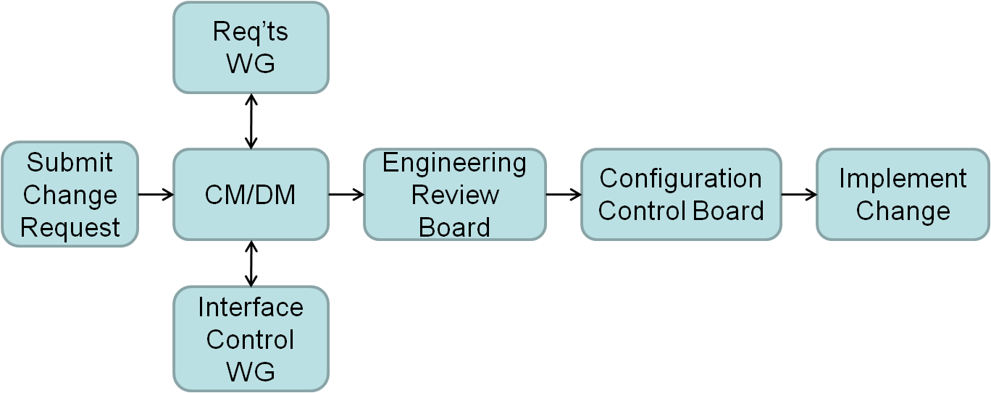

Figure 4.5-1 Configuration Management Process (mandated) (sample)

**Roles, Responsibilities, and Authorities** - Summarize the roles, responsibilities, and authorities within the CM process. If this includes one or more configuration boards, describe the hierarchy of these boards, their frequency, who (by position) chairs them, who participates, and who (by position) has final authority in each.

**Configuration Change Process** – Outline the process the program will use to change the technical baseline/configuration and specifically address:

* + - How changes to a technical baseline are identified, evaluated, approved/disapproved, recorded, incorporated, and verified;
    - How product information is captured, maintained, and traced back to requirements;
    - How requirements for in-service configuration/design changes are determined and managed/controlled; and
    - How internal interfaces are managed and controlled.

**Classification of Changes** – Define the classification of changes (Class 1, Class 2, etc.) applicable to the program.

**Roles, Responsibilities and Authorities** – Identify by position who in the CM process is responsible for determining the classification of a change and who (by position) verifies/confirms/approves it.

* Expectation: Programs will control their baselines.
  1. **Design Considerations** – DAG Section 4.4 contains a non-exhaustive list of design considerations; not all are equally relevant or critical to a given program, but all should be examined for relevancy. In the mandated table below, identify design considerations that are critical to the achievement of the program’s technical requirements. The entries below are mandated by policy for inclusion as are their reference documents which must be embedded in the SEP or hot linked.
* Expectation: SEP demonstrates that the mandated design considerations are an integral part of the design decision process including trade study criteria.

|  |  |  |  |  |  |
| --- | --- | --- | --- | --- | --- |
| **Mapping Key Design Considerations into Contracts** | | | | | |
| **Name (Reference)** | **Cognizant**  **PMO**  **Org** | **Certification** | **Documentation**  **(hot link)** | **Contractual Requirements**  **(CDRL #)** | **Description/Comments** |
| **SE Tradeoff Analysis for Affordability** |  |  | (MS B) |  | Provide the systems engineering trade-off analysis showing how cost varies as the major design parameters and time to complete are traded off against one another. The analysis will reflect attention to capability upgrades. The analysis will support MDA approval of an Affordability Requirement to be treated as a Key Performance Parameter (KPP) in the Acquisition Decision Memorandum. The analytical summary will include a graphic illustrating cost tradeoff curves or trade space around major affordability drivers (including KPPs when they are major cost drivers) to show how the program has established a cost-effective design point for those affordability drivers. |
| **Corrosion Prevention and Control** (ACAT I only) |  |  | CPCP  (MS B & C) |  | Describe how design will minimize impact of corrosion and material deterioration on system throughout system life cycle. |
| **Environmental Safety and Occupational Health (ESOH)** |  |  | PESHE  NEPA Compliance Schedule  (MS B & C) |  | * + - Describe how design will minimize ESOH by summarizing how program will integrate ESOH considerations into SE processes to include method for tracking hazards and ESOH risks and mitigation plans throughout the life cycle of system. |
| **Human Systems Integration (HSI)** |  |  |  |  | Summarize how HSI will be integrated within the SE processes, specifically addressing the human operator and maintainer requirement allocation approach that accounts for total system performance. |
| **Item Unique Identification**  **(IUID)** |  |  | IUID  Implementation  Plan (MS B & C) |  | Describe how the program will implement IUID to identify and track applicable major end items, etc. |
| **Manufacturing** |  |  |  |  | Assess the manufacturing risk and readiness of all contributory processes and particularly those that are new or unproven in a full-rate production environment. |
| **Open Systems Architectures** |  |  |  |  | Describe how open systems architectures will be incorporated into the program's design to enable affordable change, evolutionary acquisition, and interoperability. |
| **Program Protection and Information Assurance** |  |  | PPP  (MS A, B & C) |  | Describe how design will address safeguarding Critical Program Information (CPI) and provide countermeasures against hacking. |
| **Reliability and Maintainability3** |  |  | RAM contract language1  RAM-C Report2  (MS A, B, & C) |  | Describe how the program will implement and contract for a comprehensive R&M engineering program to include the phased activities in Table 4.6-2 and how R&M is integrated with SE processes. |

Table 4.6-1 Design Considerations (mandated) (sample)

**Table 4.6-1 Legend**:

Name – See DAG Chapter 4.4 for more comprehensive listing of design considerations; listed items are mandated by statute or policy and must be addressed. Others are at PMO’s discretion as appropriate for the system.

Cognizant PMO Organization – Assigned IPT/WIPT/WG for oversight

Certification – As appropriate, to include Technical Authority and timeframe

Documentation – List appropriate PMO and/or contractor documents and hot link.

Contractual Requirements – List contract clauses which the PMO is using to address the named topic.

Description/Comments – As needed, to inform other PMO members and stakeholders

1 Relevant R&M sections of the Systems Specification, SOW/SOO, and Sections L and M

2 DoD RAM-C Report Manual, June 1, 2009

3 Programs operating under Space Systems Acquisition Procedures shall address Mission Assurance (MA) planning in the context of reliability and provide a description of MA activities undertaken to ensure that the system will operate properly once launched into orbit. Specifically, space programs will describe how the Mission Assurance process employed meets the best practices described in the Mission Assurance Guide (reference Aerospace Corporation TOR-2007(8547)-6018). This description should include program phase-dependent processes and planning for MA in the next phase of the program and the way program MA processes adhere to applicable policies and guidance. Also describe the launch and operations readiness process.

|  |  |
| --- | --- |
| **R&M Engineering Activity** | **Planning and Timing** |
| R&M Allocations |  |
| R&M Block Diagrams |  |
| R&M Predictions |  |
| Failure Definitions and Scoring Criteria |  |
| Failure Mode, Effects, and Criticality Analysis (FMECA) |  |
| Maintainability and Built-in Test Demonstrations |  |
| Reliability Growth Testing at the System and Subsystem Level |  |
| Failure Reporting , Analysis, and Corrective Action System (FRACAS) |  |

**Table 4.6-2 R&M Activity Planning and Timing (mandated) (sample)**

* Expectation: Programs should understand that the content of the R&M artifacts need to be consistent with the level of design knowledge that makes up each technical baseline.

***R&M Allocations – R&M requirements assigned to individual items to attain desired system level performance. Preliminary allocations are expected by SFR with final allocations completed by PDR.***

***R&M Block Diagrams – The R&M block diagrams and math models prepared to reflect the equipment/system configuration. Preliminary block diagrams are expected by SFR with the final completed by PDR.***

***R&M Predictions – The R&M predictions provide an evaluation of the proposed design or for comparison of alternative designs. Preliminary predictions are expected by PDR with the final by CDR.***

***Failure Definition and Scoring Criteria – Failure definitions and scoring criteria to make assessments of R&M contract requirements.***

***FMECA – Analyses performed to assess the severity of the effects of component/subsystem failures on system performance. Preliminary analyses are expected by PDR with the final by CDR.***

***Maintainability and Built-In Test – Assessment of the quantitative and qualitative maintainability and Built-In test characteristics of the design.***

***Reliability Growth Testing at the System and Subsystem Level – Reliability testing of development systems to identify failure modes, which if uncorrected could cause the equipment to exhibit unacceptable levels of reliability performance during operational usage.***

***FRACAS – Engineering activity during development, production, and sustainment to provide management visibility and control for R&M improvement of hardware and associated software by timely and disciplined utilization of failure data to generate and implement effective corrective actions to prevent failure recurrence.***

* 1. **Engineering Tools** – In a table, identify the tools the program plans to use.

|  |  |  |
| --- | --- | --- |
| **Engineering Tool** | **Purpose** | **Position/IPT Responsibility** |
| IMS |  |  |
| IBM®Rational®  DOORS® | Requirements Traceability and Verification Methodology and Completion | SE IPT/Rqmts Manager |
| Requirements Verification Matrix (RVM) | Requirements Verification |  |
| Computer-Aided Three-Dimensional  Interactive Application (CATIA) | Design | SE IPT |
| Risk Mgmt Information System (RMIS) | RM | SE IPT/Risk Manager |
| SW Integration Lab (SIL) | M&S | SW WG |
| SW Engineering | Design | SW WG |
| SW cost estimating (e.g., COCOMO) |  | SW WG |
| Producibility/Throughput  Analysis Tool |  | Manufacturing WG |
| Line of Balance | Production planning | Manufacturing WG |
| Reliability Growth (e.g., RGA®, PM2, RGTM, AMPM) | Reliability growth planning and tracking | SE IPT/R&M Lead |
| Etc. |  |  |

Table 4.7-1 Engineering Tools (mandated) (sample)

* Expectation: Program should ensure design solutions are documented based upon sound SE practices using engineering tools to augment the technical approach. Programs should define tool interfaces when the government and contractor(s) plan to use different tools for the same purpose.

**Annex A – Acronyms**

Provide a list of all acronyms used in the SEP