

DEPARTMENT OF NAVY

NAVY / MARINE CORPS
Award-Fee Guide
July 2004
Table of Contents

Chapter |  | Subject |  | Page
1 |  | Introduction |  | 1
2 |  | Selection Criteria |  | 3
3 |  | Award Fee Pool |  | 5
4 |  | Funding |  | 9
5 |  | Roles and Responsibilities |  | 11
6 |  | Award Fee Plan |  | 16
7 |  | Award Fee Evaluation Process |  | 25
Appendix
A |  | Evaluation Process Flowcharts |  | A-1
B |  | Checklist |  | B-1
C |  | Award-Fee Plan Template |  | C-1
D |  | Sample Grade Definitions |  | D-1
E |  | Sample Evaluation Criteria |  | E-1
F |  | List of Acronyms |  | F-1
G |  | References |  | G-1
H |  | Examples |  | H-1
I |  | Lessons Learned |  | I-1

i

Chapter 1
1.0 -- Introduction
This guide provides guidance and a framework that should be considered and applied, as appropriate when using award fees, while leaving the Fee Determining Officer (FDO), Award Fee Review Board (AFRB) and Contracting Officer the latitude to make changes to fit the procurement. It provides information on the development of award fee plans, management of the process, evaluating contractor performance and determining the award fee to be paid. An award fee is a type of incentive and is utilized to motivate the contractor to excellent performance.

1.1 -- Award Fee
Award fee, when properly used, is a valuable contractual approach. Its application is intended to motivate the contractor’s performance in those areas critical to program success (e.g., technical, logistics support, cost, and schedule) that are susceptible to judgmental and qualitative measurements and evaluation. Objective measurements should be utilized, to the maximum extent possible, to support the subjective evaluation of the contractor’s performance. Award fee provides for a pool of dollars that can be earned based upon the Government’s evaluation of the contractor’s performance in those critical areas. An award-fee arrangement rewards good performance, incentivizes a contractor to improve performance and records the Government’s assessment of the contractor’s performance.
Award fees may be used in fixed-price, cost-reimbursement or hybrid contracts and may be used in combination with incentive fees/payments. Its use with fixed-price contracts is described in the FAR and its supplements as “fixed-price contracts with award fees” while its use with cost-reimbursement contracts is described as “cost plus–award fee contracts.” Since the FAR makes a distinction, this guide will therefore use the terms, “award-fee arrangement”, “award-fee clause”, or “award-fee incentive” to describe award fee use with all contract types.
Contracts with an award-fee incentive require periodic evaluations of the contractor’s performance throughout the life of the contract. The award-fee process allows the Government to assess and evaluate the contractors’ performance and appropriately recognize their accomplishments and provide a reward. The Government has the flexibility to consider both the contractor’s performance levels and the conditions under which these levels were achieved during the evaluation period.
In both selecting an award-fee incentive and developing the award-fee strategy, consider interrelated factors such as the dollar value, complexity and criticality of the acquisition; the availability of Government resources to monitor and evaluate performance; and the benefits expected to result from such Government oversight. Contracts containing the award-fee incentive require additional administrative and management effort and should only be used when the contract amount, performance period, and expected benefits warrant the additional administrative and management effort. Once the decision has been made to include the award-fee incentive, the evaluation plan and organizational structure must be tailored to meet the needs of that particular acquisition.
Applicable sections of FAR 16 and its supplements should be reviewed in conjunction with this guide when contemplating the use of the award fee incentive.
Definitions:
Award Fee – is an amount of money which is added to a contract and which a contractor may earn in whole or in part during performance and that is sufficient to provide motivation for excellence in such areas as quality, timeliness, technical ingenuity, and cost-effective management.
Award Fee Pool – is the total of the available award fee for each evaluation period for the life of the contract.
Base Fee – is an amount of money over the estimated costs (from zero to three percent of the estimated cost of the contract excluding facilities capital cost of money (FCCM) and exclusive of the fee), fixed at the inception of the contract, which is paid to the contractor for the performance in cost-plus-award-fee contract. Similar in nature to the fixed fee paid to a contractor under a cost plus fixed fee contract. (Base fee is not allowed in a fixed-price-award-fee (FPAF) contract however the fixed priced portion of the contract may include a normal profit. (FAR 16.404(a)(1)) The base fee should be sufficiently limited to ensure it does not undermine the effectiveness of the award structure. Be sure to apply the offset policy in DFARS 215.404-73(B)(2) for the facilities cost of money.
Fee Determining Official (FDO) – The FDO is organizationally senior to the Performance Evaluation Board and is designated by position in the award-fee plan. The FDO is responsible for determining the final award fee for each period and ensuring that the amount of the award accurately reflects the contractor’s performance.
Provisional Award Fee Payments - is the initiative (which requires the approval of one level above the PCO), which allows the AFRB, with FDO concurrence, to provide for the partial payment of the award fee during the evaluation period and before the final evaluation is made for the period. The decision to utilize a provisional payments must at least be based on the facts that (1) the successful evaluations of periods prior to the evaluation period for which partial payment is being considered, (2) the expectation that the payment of the provisional fee amounts will not reduce the overall effectiveness of the award fee incentive and (3) the contractor’s performance indicates that a significant portion of the award fee is going to be awarded at the end of the evaluation period. This initiative will improve the contractor’s cash flow situation. If this is to be authorized it should be included and delineated in the Award Fee Plan. (Effective January 13, 2004)
Rollover - is the process of moving unearned available award fee from one evaluation period to a subsequent evaluation period or periods, thus allowing the contractor an additional opportunity to earn that unearned award-fee.

Reallocation - is the process where the Government prospectively moves some or all of the award fee from one evaluation period to another or with the consent of the contractor within the current award fee period due to such things as changes to the Performance Statement of Work or Schedule, Government-caused delays, changes to special emphasis area or evaluation criteria, etc.
Chapter 2

2.0 – Selection Criteria
Award-fee arrangements are appropriate when key elements of performance cannot be objectively or quantitatively measured and areas of importance may shift over the course of the contract. Award-fee clauses can be used in contracts for research and development, major weapon systems, production items, operational contracting services, logistical support, construction, services or manpower support. For example, service contracts with an award-fee clause are used where it is difficult to define objectively what is required and what constitutes good effort. Contracts with an award-fee clause are also used to procure design, development, and initial fabrication of state-of-the-art weapon systems when technical challenges are difficult to measure objectively. The award-fee incentive may also be applied in Commercial Item contracts to incentivize contractor performance in the areas of quality and schedule, but not in the area of cost. Before entering into an award-fee arrangement, the acquisition team should consider the factors summarized below.
When deciding to use award fee the contracting officer should adequately document the contract file. The documentation should include:
- Justification for the use of an award fee over other incentives or contract types and
- An analysis that determines that the additional administrative effort and cost required to monitor and evaluate performance is justified by the expected benefits.
In the development of the acquisition plan, the acquisition team should discuss and document the factors and the reasons why an award-fee contract is the appropriate contract type; some of the factors to consider are listed below:

Contractor Motivation
Use of an award-fee incentive motivates the contractor to concentrate resources in areas critical to program success. The award-fee plan should identify the specific areas of performance that are most important to the program’s success. An objective in negotiating an award-fee arrangement is to achieve effective communication between Government and contractor personnel at all levels to achieve desired results.

Administrative Cost Versus Expected Benefits
The most obvious Government administrative cost is the labor resource dedicated to continuously monitor performance. Although monitoring performance is necessary for all contract types, the award-fee evaluation process is a structured approach that requires additional documentation and briefings. Since award-fee evaluation periods will continue throughout the award-fee period of the contract, total administrative cost is the sum of all evaluations. Performance monitoring, reporting, and documentation continue throughout all award-fee periods, which may include option periods. (Remember to also consider the cost (inclusive of man-hours) to educate and train technical personnel, Performance Monitors, Award Fee Review Board members, and other related acquisition personnel before implementation of the contract. The need to provide continuous follow-on training should also be considered.)
An analysis in accordance with FAR 16.405-2(c) should be performed to demonstrate that the expected benefits are sufficient to warrant the additional effort and cost involved with managing and administering the award-fee process. Defense Federal Acquisition Regulation Supplement (DFARS) 216.470 extends this requirement to other types of contracts by listing that the “award amount” portion of the fee may be used in other types of contracts under certain conditions. The fifth condition in DFARS is, “The administrative costs of evaluations do not exceed the expected benefits.” Therefore, the acquisition team should analyze the anticipated benefits versus added administrative costs before selecting the award-fee incentive. Since both the anticipated benefits and added administrative costs are judgmental, the benefit analysis may not be a quantifiable analysis.

Contract Value
Avoid using dollar thresholds as the sole determinant to select use of award-fee. Estimated contract dollar amount is only one measure of value and may not be the most important consideration. Instead, consider contract value in terms of the criticality of the acquisition and its impact on related efforts. A relatively small dollar value contract may be extremely significant to the overall major program and, therefore, require the flexibility and judgmental evaluation inherent in using the award-fee incentive.

Hybrid Contracts
When portions of a contract effort are suited to objective/quantitative measurements and others are not, a hybrid or combined contract type of award fee and incentive fee may be used. With different levels of uncertainty and risk, different contract types may be appropriate within a contract. Use caution in establishing hybrid contracts to ensure that an award-fee incentive does not conflict with or de-incentivize the incentive-fee objectives.

Contractor Performance Appraisal Report System (CPARS)
The CPARS shall not be used as part of the award fee criteria. However, the fee amount paid to the contractor should be an indicator of the contractor’s performance and the past performance appraisal should complement the award fee determinations. In short, the goal is to ensure that all performance assessments, award fee determinations, incentive allocations or any other performance measures be evaluated consistently throughout the contract performance.

Earned Value Management
Earned value may be used as part of the award fee criteria if it is consistent with the factors that are being utilized to improve the contractor’s performance. Whether used as a criteria or not, there should be some consistency between the appraisal of the contractors performance in the award fee, CPARS and the results of earned value.
Chapter 3

3.0 – Award Fee Pool
The award-fee pool is the total of the available award fee for each evaluation period for the life of the contract.

3.1 -- Base Fee
Base fee is an amount of money over the estimated costs (from zero to three percent of the estimated cost of the contract excluding FCCM and exclusive of the fee (see DFARS 216.405-2(c)(ii)(2)(B)), fixed at the inception of the contract, which is paid to the contractor for the performance in cost-plus-award-fee contract. Base fee is fixed at the inception of the contract and is not subject to adjustment based upon the level of contractor’s performance. A base fee is not allowed in a fixed price contract, although a normal profit may be included in arriving at the fixed portion of the price. Your acquisition strategy determines the amount of base fee to include in the award-fee pool. The use of base fee enhances a contractor’s cash flow, but it may be unnecessary if the CPAF portion is combined with other types of contracts. When developing a base-fee objective for CPAF contracts, see DFARS 215.404-74(c) for application of the DoD Offset Policy for Facilities Capital Cost of Money.

3.2 -- Award-Fee

Award fee is an amount of money which is added to a contract and which a contractor may earn in whole or in part during performance and that is sufficient to provide motivation for excellence in such areas as quality, timeliness, technical ingenuity, and cost-effective management. The available award fee portion of the award-fee pool is allocated to each award-fee evaluation period and is earned based upon the contractor’s performance for that evaluation period. Since the available award fee during the evaluation period must be earned, the contractor begins each evaluation period with 0% of the available award fee and works up to the evaluated fee for each evaluation period. Contractors do not begin with 100% of the available award fee and have deductions taken to arrive at the evaluated fee for each evaluation period. However, the potential for the contractor to earn 100% of the award fee amount should be a mutual goal as it demonstrates the program’s objectives were clearly communicated and achievable.

3.3 -- Establishing the Award-Fee Pool
Establishing the award-fee pool is critical and requires careful consideration. Potential fees must be sufficient to provide the contractor motivation to achieve excellence in overall performance. The potential fees should not be excessive for the effort contracted nor should they be so low that the contractor has limited incentive to respond to Government concerns. An inadequate award-fee pool does not provide the motivation to the contractor that this type of contract is intended to stimulate.
There is no single approach required by FAR for establishing the amount of an award-fee pool. However, it should be logically developed and reflect the complexity of the contract effort. In FPAF contracts, the award fee shall not apply to cost reimbursable items (e.g., travel and material).
When the award-fee pool is evaluated considering the following factors, the pool should be sufficient to compensate the contractor for the highest level of performance. If not, the pool or performance goals should be adjusted accordingly, while keeping reasonableness in mind.
• Complexity of the work and the resources required for contract performance.
• Reliability of the cost estimate in relation to the complexity and duration of the contract task.
• The performance factor you are attempting to improve or goal you are attempting to obtain and the motivation necessary to make that happen.
• The degree of cost responsibility and associated risk that the contractor will assume because of a contract with an award-fee clause.
• Amount of base fee, if applicable. (Remember to apply the DoD Offset Policy for Facilities Capital Cost of Money in calculating the pre-negotiation base-fee amount.)
There are different methods that can be used to establish the award-fee pool. Most award fee positions are supported by unstructured methods. The methods listed below are possible approaches:
• Review past acquisition history/experience
• Research current award-fee pools for similar efforts
• Establish evaluation criteria and apply a percentage based on risk and importance
• Cash flow /Proposed expenditure profile analysis

3.4 -- Allocation of Award Fee by Evaluation Period
After the amount of the award-fee pool is established, allocate the pool over the various award-fee evaluation periods. The distribution of the award-fee pool depends on the acquisition strategy and individual circumstances of each procurement. The available award fee allocated for each evaluation period is the maximum amount that can be earned during that particular evaluation period. The available award fee may be allocated equally among the evaluation periods if the risks and type of work are similar throughout the various evaluation periods. Otherwise, if there is greater risk or critical milestones during specific evaluation periods, a larger portion may be distributed to those periods. This permits the Government to place greater influence on those evaluation periods. The same holds true for additional award fee amounts based on modifications to the contract. Distribution of any additional available-award-fee

dollars should be tailored to the specific acquisition. The following dollar amounts are provided for the examples in 3.4.1 -- Equal Allocation and 3.4.2 -- Unequal Allocation.
 | Estimated Cost excluding FCCM | $5,000,000
 | Award Fee (10%) | $500,000
 | Base Fee (2%) | $100,000
 | Total | $5,600,000

3.4.1 -- Equal Allocation
The total available award fee ($500,000) may be allocated equally among the evaluation periods as shown below if the risks and type of work are similar throughout the various evaluation periods.
Evaluation Periods | 1 | 2 | 3 | 4 | Total
Allocation (%) | 25% | 25% | 25% | 25% | 100%
Allocation ($) | $125,000 | $125,000 | $125,000 | $125,000 | $500,000

3.4.2 -- Unequal Allocation
Unequal allocation of the available award fee ($500,000) should be used to motivate the contractor’s performance to correspond to different degrees of emphasis or risk. If the contract has a short initial evaluation period so the contractor becomes familiar with the work (e.g., janitorial services), the initial evaluation period may have a smaller allocation while the remaining available award fee is divided equally among the remaining evaluation periods. Conversely, if the contract effort requires the contractor to become familiar with the work quickly, the initial evaluation period may have a larger allocation. If there is greater risk or a critical milestone(s) during specific evaluation periods, a larger portion of the award-fee pool may be distributed to certain periods. Also, allocate the available award fee so that it remains an effective incentive throughout contract performance. Sometimes, by allocating significant award fee amounts for early critical milestones, not enough award fee is allocated to evaluation periods towards the end of the contract when overall contract performance can be judged. Unequal allocation permits the Government to place greater emphasis on certain award-fee evaluation periods. The following illustrates an unequal allocation that reflects different degrees of emphasis.
Evaluation Periods | 1 | 2 | 3 | 4 | Total
Allocation (%) | 10% | 26% | 40% | 24% | 100%
Allocation ($) | $50,000 | $130,000 | $200,000 | $120,000 | $500,000

3.4.3 -- Award-Fee Hourly Rate Allocation
The available award-fee amounts can also be calculated by multiplying the maximum or estimated hours by an established award-fee hourly rate before the evaluation periods start for cost-reimbursement term contracts. The available award-fee amount at the end of each evaluation period is then determined by multiplying the number of hours incurred or authorized, whichever number of hours is less, times the award-fee hourly rate. The contractor’s performance must still be evaluated at the end of the evaluation period to determine the award-fee amount earned by the contractor. When this method is used, extra care is needed to ensure that the number of hours the contractor used bears a reasonable relationship to the accomplishments during the period. Cost control is minimal in these situations especially where the type or quality of labor used can fluctuate.

3.4.4 -- Reallocation
Reallocation is the process by which the Government moves a portion of the available award fee from one evaluation period to another or with the consent of the contractor within the current award fee period due to such things as Government-caused delays, special emphasis areas, changes to the Performance Work Statement (PWS) or Statement of Work (SOW), etc. Reallocation is not normally associated with the contractor’s performance. Reallocation may be done unilaterally if projected before the start of the affected award-fee evaluation period. Within an award-fee evaluation period, reallocation can only be done by mutual agreement of both parties. In all cases where the reallocation is done, the contracting officer should ensure that the contract file is documented to justify the reason for the change and discuss why the reallocation is beneficial to the Government.

3.5 – Special Award Fee Clauses
3.5.1. — Rollover
Rollover is the process of moving unearned available award fee from one evaluation period to a subsequent evaluation period, thereby providing the contractor an additional opportunity to earn that unearned award-fee amount. To maintain the integrity of the award-fee evaluation process, rollover should occur only in exceptional cases. There are instances when it is advantageous to add additional incentives for improved contractor performance. If the FDO concurs with the use of rollover, documentation that justifies its use must be included in the official contract file and be approved by an individual one-level above the contracting officer. The rollover process should be fully delineated in the award fee plan or incorporated into the plan when the decision is made to use rollover.
3.5.2. — Systemic Improvement
In some instances the AFRB or the FDO may desire to establish a clause as part of the award fee determination process that would allow for the rollover of the unearned funds for systemic improvements. This clause should be very specific and adequately provide evaluators with desired achievement/performance requirements.
[Special Note: Award-fee payments are bona fide needs of the same fiscal year and appropriation that finance the related contractual effort on which the award-fee determination is based. Since both the bona fide need and propriety of funds (purpose) rules apply, sufficient funds must be available for payment of the rollover amount and must be of the correct appropriation (type and year) for the related effort in the subsequent evaluation period.]
Chapter 4

4.0 -- Funding
Award-fee pools are budgeted as part of the total contract budget. When planning and budgeting for award fees, you must adhere to bona fide need and funding propriety (or purpose) rules. The bona fide need rule, 31 U.S.C. 1502(a), provides that: “The balance of an appropriation or fund limited for obligation to a definite period is available only for payment of expenses properly incurred during the period of availability or to complete contracts properly made within that period of availability and obligated consistent with section 1501 of this title.” The propriety of funds rule, 31 U.S.C. 1301(a), says, “appropriations shall be applied only to the objects for which the appropriations were made.”
An award-fee requirement is a bona fide need of the same year and appropriation that financed the related effort against which the award fee was earned. From propriety of funds’ standpoint, award fees are inherently inseparable from the work with which they are associated. This means the financial manager will plan and budget award fees in the same fiscal year and appropriation as the related effort. This includes award-fee amounts that cross fiscal years. If an unearned award-fee amount is moved to a subsequent evaluation period, there must be sufficient funds of the same year and appropriation as for the work performed in the subsequent evaluation period. (For more information, see 3.5, Rollover.)
To comply with appropriation law and RDT&E incremental funding policy, award fees must be budgeted for and funded with the same fiscal year funds as the increment of associated effort. For procurement appropriations, appropriation law and DoD full funding policy mandate that award-fee pools are funded with the same appropriation and fiscal year funds as the associated effort.

4.1 -- Commitment of Award Fees
The Department of Defense Financial Management Regulation (DoDFMR) (DoD 7000.14-R) requires that when a CPAF contract is executed, an obligation be made which may not be in excess of the current liability, which includes the base fee. Thus, the award-fee amount available for each specific award-fee evaluation period should be certified and administratively reserved (committed) as a contingent liability before the beginning of the applicable award-fee evaluation period. Funds should be committed for the full amount of the contingent liability that the available award fee for that period represents. This allows for quick payment to the contractor after issuance of the FDO determination and communicates a clear message to all involved in the award-fee process that earning 100% of the available fee is possible.

4.2 -- Obligation and Payment of Award Fees
Earned award-fee amounts are obligated by issuance of a contract modification after the completion of the award-fee evaluation period prior to payment. Award-fee determinations made after the funds have expired require special consideration. These constitute upward obligation adjustments to expired appropriations and must be approved by the Assistant Secretary of the Navy for Financial Management and Comptroller (ASN (FM&C)) if over $1,000,000 and by the funds authorization holder if under $1,000,000.
Concerning the proper fiscal year and appropriation to pay an award fee, remember this simple rule: The same fiscal year and appropriation used to fund the related contractual effort will be used to pay the earned award fee. In the event funds reserved for award fees have canceled, then current year funds must be made available. If you have any questions regarding the appropriate fiscal year to pay an award fee, ask your financial representative.

Chapter 5

5.0 – Roles and Responsibilities
Evaluations for award fee are judgmental due to the nature of the work. Therefore, it is especially important that all personnel involved understand the overall process, and the specific roles and responsibilities of the evaluation team. The award fee evaluation team includes a Fee Determining Official (FDO), an Award Fee Review Board (AFRB) including a Chairperson and the Contracting Officer or his representative, and Performance Monitors. The FDO makes the final determination regarding amount of award fee earned during the evaluation period and ensures the award-fee process integrity is maintained. The AFRB provides an objective, impartial view of the contractor’s performance to the overall process. The Performance Monitors deal with the contractor on a day-to-day basis and provide reports to the AFRB.
Although uses of award fee allow for subjective evaluation of the contractor’s performance, it must be a disciplined approach. Documentation ensures the integrity of the evaluation process. Therefore, this documentation should demonstrate that the process set forth in your award fee plan has been followed, that the rating recommendations and final determinations have been based on actual performance and evaluated according to the award-fee plan, and that timely feedback was provided to the contractor that addressed strengths and weaknesses.
The award fee organizational structure should be as simple as possible and avoid an excessively structured evaluation process. Excessive layers can hamper the flow of information and cause unnecessary paperwork, delays in turnaround, and put large demands on the work force.

5.1 -- Fee Determining Official (FDO)
The FDO is designated by position in the award-fee plan. The FDO must be senior enough to ensure the contractor’s confidence in the objectivity of the award-fee process and enable communication with the appropriate level of contractor management.
The FDO ensures the amount and percentage of award fee earned accurately reflects the contractor’s performance. The FDO’s decision must be documented. If the FDO’s determination varies either upward or downward from the AFRB’s recommendation, the rationale for the change should be documented in the official contract file and explained with reference to the award-fee plan. Since award-fee determinations are subject to the Disputes clause, the documentation is necessary to ensure the FDO decision does not appear arbitrary and capricious.
The FDO determination letter should include the earned-award-fee amount and address the contractor’s strengths and weaknesses for the evaluation period. The FDO determination letter should not include:
(1) names of individuals that work for the contractor,
(2) internal rating scores of AFRB members or,
(3) internal rating tools, such as stars, arrows, etc.
The FDO determination letter shall be sent to the contractor under CO cover letter within 45 days after the end of the evaluation period. The contract modifications providing the funds or release of the funds should be delivered to the contractor within 15 days of the FDO determination.

5.2 -- Award Fee Review Board
The AFRB evaluates the contractor’s overall performance for the award-fee evaluation period, and recommends the earned-award-fee amount to the FDO. The AFRB reviews the Performance Monitors’ evaluations, the contractor’s self-evaluation, and other pertinent information to arrive at an overall evaluation of the contractor’s performance. The AFRB may request that Performance Monitors discuss their evaluations in person so that the AFRB gains further insight into the contractor’s performance. The AFRB may also have contractor representatives provide a briefing regarding their self-evaluation and clarification of any issues. The AFRB may also recommend changes to the award-fee plan for future periods to the appropriate approval authority. The AFRB is also responsible for preparing interim evaluation reports to provide formal feedback to the contractor during the evaluation period.
The AFRB is composed of Government personnel only whose experience in acquisition allows them to analyze and evaluate the contractor’s overall performance. The only required members of the AFRB are a Chairperson, the CO or his representative, and a Recorder. (The Contracting Officer may not be the Chairperson or the Recorder.) The AFRB should not include Performance Monitors and contractor personnel should not be present during evaluation discussions nor during presentations made by Performance Monitors. AFRB membership may also include personnel from key organizations knowledgeable of the award-fee evaluation areas such as: Engineering, Logistics, Program Management, Contracting, Quality Assurance, Legal, and Financial Management; personnel from the user organizations and cognizant contract administration office (CAO); and the local Small Business Office in cases where subcontracting goals are important. Members should be identified only by position to eliminate the need for administrative changes to the award-fee plan when an individual member changes. AFRB members:
• Should be familiar with the award-fee process, contract requirements, and the award-fee plan.
• Assess the contractor’s overall performance for each award-fee plan criterion. It is critical that the AFRB evaluate the contractor’s overall performance according to the criteria stated in the award-fee plan.
Document the AFRB’s results to show what factors were considered and how the AFRB arrived at the recommended earned-award-fee amount presented to the FDO. This documentation may include Performance Monitors’ evaluations; interim letters, if applicable; the contractor’s self-evaluation, if any; briefings presented to the AFRB; and other data considered.

5.2.1 -- AFRB Chairperson
The AFRB Chairperson is appointed by position by the FDO. The AFRB Chairperson:
• Interfaces with and briefs the FDO on recommended earned-award-fee amounts and the contractor’s overall performance.
• Recommends significant award-fee plan changes to the FDO.

5.2.2 -- Contracting Officer or representative
The CO or a representative is a member of the AFRB and is the official liaison between the Government and the contractor. The CO transmits FDO letters to the contractor. The CO prepares and distributes the modification awarding the fee authorized by the FDO within 15 calendar days after the FDO determination. The CO should confirm that the award-fee amount is certified (committed) and administratively reserved prior to the beginning of the applicable award-fee evaluation period. The CO should ensure that all unearned-award-fee funds are promptly de-committed or de-obligated, as appropriate, after each evaluation period unless a rollover is authorized. The CO must notify the contractor in writing of any change(s) to the award-fee plan, after FDO/AFRB Chairperson approval and before commencement of the award fee period.
A paper trail must be maintained to substantiate the AFRB recommendation and FDO determination. In addition to the required documents already in the official contract file such as the award-fee plan, appointment letters, etc., the official contract file should also contain the following documentation for each separate evaluation period:
• A copy of the FDO briefing.
• A copy of the FDO’s determination letter to the contractor providing the earned-award-fee amount, strengths, weaknesses, and future areas of emphasis, if any.
• Supporting rationale if the FDO’s determination of earned-award-fee amount differs from the AFRB recommendation.
• A copy of the Recorder’s records of the AFRB should be filed in the contract file.
• Justification and approval for the use of rollover and amount of unearned award fee to be available, if applicable.
• Interim evaluation letter, if applicable.
• Contractor’s self-assessment, if any.
• Funding documents.

5.2.3 -- AFRB Recorder
The AFRB Recorder, who is designated by the AFRB Chairperson, is the administrative backbone of the award-fee process. The Recorder is responsible for coordinating the administrative actions required by the FDO, AFRB, and Performance Monitors. Any member except the CO may perform this position in conjunction with other functions on the AFRB. In some large programs with numerous performance monitors, an intermediate position between the AFRB and performance monitors may be established to consolidate the evaluations from the various Performance Monitors. The Recorder:
• Notifies Performance Monitors that their evaluations are due.
• Receives, processes and distributes evaluation reports from all required sources and maintains official files.
• Schedules and assists with internal evaluation milestones, such as briefings.
• Accomplishes other actions required to ensure the smooth operation of the award-fee process, such as documenting the AFRB activities.
• Retains all Performance Monitors’ evaluation reports, if they are not included in the official contract file.
• Retain other pertinent data not contained in the official contract file.

5.3 -- Performance Monitors
Performance Monitors provide the day-to-day evaluation of the contractor’s performance in specifically assigned areas of responsibility. This monitoring is the foundation of the award-fee evaluation process.
Performance Monitors are working-level specialists, such as engineers, cost analysts, Quality Assurance Evaluators (QAEs), or Functional Area Evaluators (FAEs), familiar with their assigned evaluation areas of responsibility and interface directly with the contractor. Performance Monitors should not be members of the AFRB. Performance Monitors:
• Should be familiar with the contract requirements, applicable specifications, processes, standards, and the award-fee plan, especially the performance rating criteria for their assigned evaluation area(s).
• Conduct all assessments according to contract requirements and the award-fee plan so that evaluations are fair and accurate.

• Maintain written records of the contractor’s performance in their assigned evaluation area(s) that detail specific examples where
(1) improvement is necessary or desired;
(2) improvement has occurred; and
(3) performance is below, meets or exceeds contract requirements.
• Prepare interim and end-of-period evaluations as directed that address the contractor’s weaknesses and strengths.
• Be prepared to brief the AFRB on their specific evaluation area(s).
• Recommend changes to the award-fee plan; e.g., award-fee pool reallocations, performance area weights, evaluation criteria.
Performance Monitors should provide justification for their ratings and document both strengths and weaknesses in their areas of responsibility. It may be helpful to have a worksheet for each category of performance and evaluation criteria that mirror the award-fee plan. The Performance Monitors’ written records should be maintained until contract closeout.

Chapter 6

6.0 – Award Fee Plan
The award-fee plan maps out the award fee process and defines the areas in which emphasis is required by the contractor and how that will be evaluated. The plan details the procedures for implementing the award-fee clause of the contract. The Award Fee Plan may be attached to the contract as one of the Appendixes supporting the Award Fee clause normally found in Section H of the contract. However, since the Award Fee Plan dictates the actions of the government team in the evaluation process, it is not necessary that it be attached to the contract. The award-fee plan structures the methodology of evaluating the contractor’s performance during each evaluation period. The objectives of the plan are to
(1) provide a workable process with a high probability of successful results,
(2) clearly communicate evaluation procedures that provide effective, two-way communication between the contractor and the Government, and
(3) focus the contractor on areas of greatest importance to motivate the best possible performance.
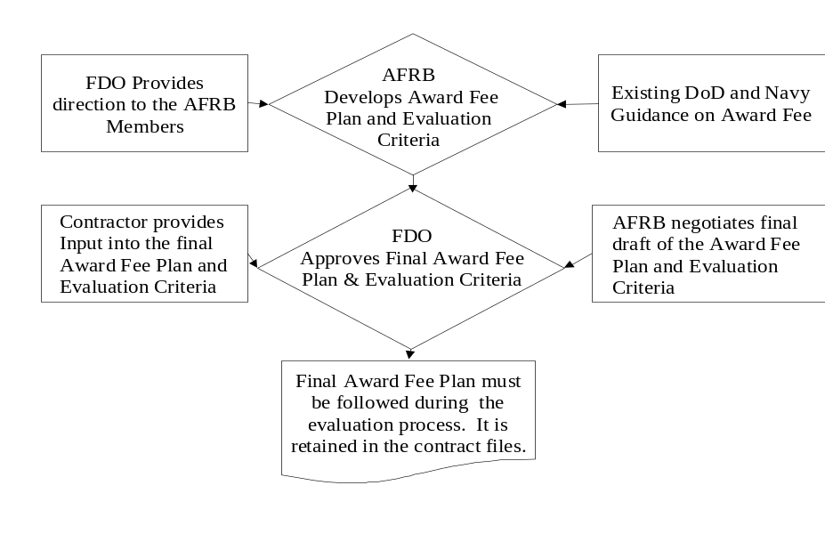

Figure 1 Award Fee Plan Development Process

In developing an award-fee plan, keep in mind that it should:
• Identify the responsible persons and detail their responsibilities, preferably by position. (See 6.1, Organization.)
• Describe the overall evaluation process by establishing an effective organizational structure commensurate with the complexity and dollar value of the particular acquisition.
• List the evaluation periods and respective fee allocations. (See 6.2, Evaluation Period Length and Allocation.)
• Identify the grades used for measuring the contractor’s performance. (See 6.3.1, Grades.)
• Identify each category and subcategory of performance. (See 6.3.2, Categories of Performance.)
• Define the evaluation criteria used to grade the contractor’s performance. (See 6.3.3, Evaluation Criteria.)
• List weights, if any, to be applied to each category and subcategory of performance to the evaluation criteria, where possible. (See 6.3.4, Weighting of Categories of Performance.)
• Identify procedures for changing the plan. (See 6.7, Procedures for Changing the Award-Fee.)
The following sections discuss the various elements of an award-fee plan. (See Annex B, Checklists, and Annex C, Award-fee Plan Templates.) The plan should be as elaborate as necessary to achieve the desired results. Normally for smaller programs, award-fee plans do not need to be as elaborate as for larger programs; however, the plan should, as a minimum, address each item listed above. Every award-fee plan should have the following elements:
• Title Page containing the name of the program, RFP/contract number, and coordination/approval signatures and dates.
• Introduction describing the responsibilities and procedures for implementing the award-fee clause of the contract.
• Organization including identification of the FDO, Award Fee Review Board (AFRB) members and Performance Monitors.
• Evaluation Process including the grades, categories and subcategories of performance, evaluation criteria, and weights, if applicable.

6.1 -- Organization
Identify the FDO and AFRB members by title/position to eliminate the need for administrative changes to the plan when an individual member changes. Performance Monitors are identified by function in the plan. For more information, see Chapter 5, Roles and Responsibilities.

6.2 -- Evaluation Period Length and Allocation
The total contract performance should be divided into evaluation periods. Evaluation periods can end on specific dates or milestones. If milestones are used, evaluation periods shall end at milestone completion. For award fee allocate the amount of available award fee over the evaluation periods. Common award fee periods are 3 to 6 months in duration, but the length of the evaluation periods and allocation of the available award-fee pool depend on the contract, acquisition strategy, and program needs and goals of the procurement. (See 3.4, Allocation of Award Fee by Evaluation Period, for further information.)
The evaluation periods can be established by duration with start and end dates. If duration is used, evaluation periods need not be equal in length. In some instances (e.g., janitorial services), the contractor may need a short initial evaluation period to become familiar with the work required while the remaining periods of performance are divided equally. The evaluation periods can also be established by performance milestones with specific anticipated milestone completion dates. If milestones are used, the actual evaluation period should end at the completion of the milestone.
When determining the appropriate length for evaluation periods, there are pitfalls to be avoided. Evaluation periods that are too short can prove administratively burdensome, lead to hasty evaluations or late award-fee determinations, and allow insufficient time for the contractor to improve areas of weakness. Evaluation periods that are too long jeopardize effective formal communication between contractor and Government and diminish opportunities to influence the contractor’s performance. Evaluation periods should not exceed six months for small businesses or one year for large businesses. Performance feedback should occur not only at scheduled intervals but should be provided continuously to the contractor. Continuous communication between the Government and the contractor is critical to their performance as a team and to program success.
The Government may unilaterally reallocate or revise the distribution of remaining award-fee dollars among subsequent evaluation periods. (See 3.4.4, Reallocation.) The CO must notify the contractor of such changes in writing before the relevant evaluation period starts. The award-fee plan should be modified accordingly. If the total award-fee pool and available award-fee dollars for each period are stated in the contract, a contract modification should also be issued. After an evaluation period begins, changes impacting that evaluation period may only be made by mutual agreement.

6.3 -- Evaluation Requirements
Even though the evaluation can be subjective, every effort should be made to make the criteria and the measurement of the criteria as clear and understandable as possible. Including the contractor in the development of the criteria and the performance measures is another method that can be taken to help ensure mutual understanding. Clear and measurable criteria also help the FDO ensure that the final determination is based on preset objectives and not anecdotal examples of performance brought forward at decision time.

A critical part of developing the plan is defining the grades, categories of performance, and evaluation criteria. Each of the three to five grades used to evaluate the designated categories of performance may have a range of performance points assigned to it. Grades, categories of performance, and associated criteria are specific to the needs and goals of the contract and program.

6.3.1 -- Grades
It is recommended that three to five standard grades be used to evaluate the contractor’s performance. The plan should include the range of grade points or scores assigned to each grade. Calculate the overall performance score by totaling the sum of the weighted grade points (if weights are used) for each category of performance. Grade descriptions are not standardized to allow tailoring to your acquisition. (Examples of grade descriptions are in Annex D, Sample Grades. Remember to tailor your descriptions to reflect the facts and circumstances of your particular procurement.)

6.3.2 -- Categories of Performance
The award-fee plan lists the categories of performance (e.g., technical, management, schedule and cost) to be evaluated and the associated weights, if any. Spreading the grading over a large number of categories can dilute the emphasis but can be effective if properly weighted. You may prefer to use broad categories such as technical, business management and cost control, supplemented by a limited number of criteria describing significant evaluation elements over which the contractor has effective management control. Program history, past performance and award objective will be helpful in identifying key problem or improvement areas to focus on during evaluations.
Award-fee plans are tailored to the strategy of the individual procurement. There is no requirement to standardize the categories of performance. It is neither necessary nor desirable to include a category of performance for each function in the statement of work. If the contract is for services, the quality assurance evaluation process can be accomplished under the purview of the award-fee plan. A separate surveillance plan would only be required for those areas of the contract not covered by the award-fee plan. Categories of performance incentivized should be important to the success or failure of the program so neither the Government nor contractor uses inordinate resources on minor tasks to the detriment of major tasks or program. The functions included in the plan should be balanced so that contractors, making trade-offs between categories of performance, may assign the proper importance to all the critical functions identified. For example, the award-fee plan in a cost contract should emphasize technical performance, product management and cost control considerations because an evaluation limited to technical performance might result in increased costs that are out of proportion to any benefits gained.
Some basic areas of performance need to be in every award-fee plan. For instance, all cost-reimbursement incentive-type contracts are required to include a cost incentive or constraint. Therefore, cost control should always be evaluated in CPAF contracts. In general, controlling the cost, quality (technical merit, design innovation, reliability, etc.), and scheduled delivery of hardware or services provided will always be important. However, the relative importance and measure of performance in each area will vary according to the needs of each acquisition.

6.3.3 -- Evaluation Criteria
The award-fee plan must state the evaluation criteria used to grade each category of performance. The criteria should emphasize the most important aspects of the program that will motivate the contractor in a positive way to maximize performance. The criteria should be specific to the needs and goals of the program. Award-fee plans whose criteria are either too broad, or inapplicable to a given function, make it difficult for Performance Monitors to provide meaningful comments and evaluations.
The criteria and the evaluations against those criteria should be clear and understandable to the contractor. Understanding the criteria and what is important gives the contractor a clear picture of what it takes to obtain 100% of the available award fee. The contractor earning 100% indicates the program’s objectives were communicated and achieved. Contractor input into the development of the plan is an effective method of helping the contractor understand program requirements and objectives.
Depending upon the procurement situation, performance evaluation criteria may include output, input or a combination of both factors. Output factors refer to the end results of contract performance, such as the quality of the end items delivered or services rendered, the actual time of delivery or completion, and the incurred costs. Input factors refer to intermediate processes, procedures, actions, or techniques that are key elements influencing successful contract performance. These include testing and other engineering processes and techniques; quality assurance and maintenance procedures; subcontracting with small and small disadvantaged businesses; purchasing department management; and inventory, work assignment and budgetary controls to name a few.
Although award-fee uses subjective evaluations, objective measurement of contractor performance to support the evaluation is an approach that most clearly articulates to the contractor what is expected to be achieved for program success during the evaluation period. Using this approach, categories of performance are still identified, but measurable outputs are determined before the evaluation period begins to communicate what performance level is necessary to achieve a particular rating. For example, if improving productivity/performance is established as an objective, metrics are developed and established to measure performance within that productivity/performance category. Within each metric, performance levels are identified to rate contractor performance. If completion of productivity initiatives is identified as a metric for improving productivity/performance, it could be predetermined that 90% -- 100% is an excellent, 80% -- 90% a very good, etc. The metrics provide an indication of contract performance for a particular category and are an input for the overall subjective evaluation of that category. (See Performance Assessment Matrix Template in Annex E for further information).
Examples of categories of performance and associated criteria are shown in Annex E, Sample Evaluation Criteria. These examples do not cover all possibilities, but they illustrate some of the categories of performance.

6.3.4 -- Weighting of Categories of Performance
As contract work progresses from one evaluation period into the next, the relative importance of specific performance criteria may change. The award-fee plan may indicate the relative priorities assigned to the various categories of performance through percentage weightings. Weights should be used to communicate relative priorities; the total assigned weights must equal 100 percent.

6.4 -- Grading and Scoring Contractors Performance
Grading and scoring methods translate evaluation findings into recommended performance ratings. For award-fee the contractor begins the evaluation period with 0% of the available award fee and works up to the earned award fee based on performance during that evaluation period. Contractors do not begin with 100% of the available award fee and have deductions taken.
Some general considerations in the development of a grading/scoring methodology are:
• When Government actions impact contractor’s performance either positively or negatively, consider those actions in the scoring and grading process. Such Government actions include changes in funding allocation or increased emphasis on certain technical requirements that require the contractor to make unexpected and extensive trade-offs with other technical requirements.
• Keep the process as clear and simple as possible.
• The entire available award-fee amount or highest possible rating should be potentially attainable.
• Documentation regarding the contractor’s performance should be available for the FDO’s review before a final evaluation decision for the evaluation period is made. Documentation of assigned grade points, if grade points are used, is required to support recommendations.
When cost control is included as a factor in the plan, measure the contractor’s success at controlling cost. The following scoring guidelines will help ensure that cost control receives the proper emphasis:
• If there is a cost overrun, consider the reasons for the overrun and the contractor’s efforts to control or mitigate it. If there is a significant cost overrun that was within the contractor’s control, a score of zero may be given.
• If there was a cost overrun in the previous evaluation period, consider the contractor’s efforts to control or mitigate it. If the cost overrun continues to grow and was within the contractor’s control, a score of zero may be given. If the overrun is lessening, a higher score may be given.

• If the maximum score for cost control is given when the contractor achieves the negotiated estimated cost of the contract, evaluation factors may be set to low and there might be no incentive for cost underruns. Some lesser score must be assigned indicating the degree to which the contractor has prudently managed costs while meeting contract requirements.
• Cost underruns within the contractor’s control will normally be rewarded. However, cost underruns may not indicate good cost control unless the actual effort during the evaluation period matches that originally proposed or planned. The extent to which the underrun is rewarded should depend on the size of the underrun and the contractor’s level of performance in the other categories of performance.

6.5 -- Award-Fee Conversion Tables
Award-fee plans may include conversion tables or graphs with formulas that translate the contractor’s overall score (i.e., performance points) into the earned award-fee amount. This conversion does not have to be a linear relationship. The earned award-fee amount indicated by the use of a conversion table or graph is a guide to the AFRB and FDO. Use of a conversion table or graph does not remove the element of judgment from the award-fee process. Regardless of the method used, zero award fee will be earned for an overall unsatisfactory performance.

6.5.1 -- Linear Relationship Between Score and Fee Percentage
One method of conversion is linear, a straight point-to-percentage conversion of overall performance above Unsatisfactory. For example, if a contractor receives an excellent grade with an overall score of 91, the contractor would also receive 91% of the available award fee for that evaluation period. A more aggressive reduction can also be applied for example where you might have Numerical Rating/2= earned award fee, this would result in a 2 percent reduction for every for each point dropped. Other linear formulas/relationships may be developed to support specific procurements. Usually the linear method is the less preferred method of award fee determination because it doesn’t emphasize specific periods and the need for increased performance during those periods.

6.5.2 -- Non-Linear Relationship Between Score and Fee Percentage
The following graph depicts usage of non-linear relationships between points and percentage of overall performance above Unsatisfactory. The grades in this example are:
 | Unsatisfactory | Below 70
 | Satisfactory | 71-80
 | Very Good | 81-90
 | Excellent | 91-100

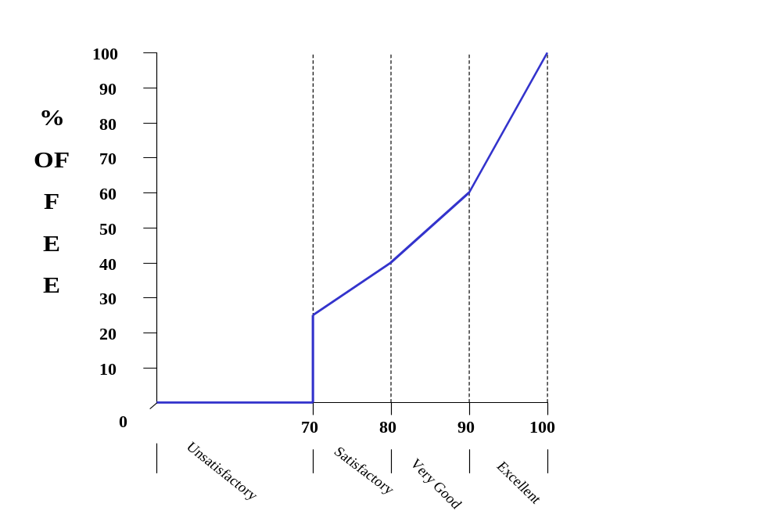

Figure 2 -- Non-Linear Relationships of Above Unsatisfactory Performance
In this example, an overall score of 80 points receives 35% of the available award fee; an overall score of 87 points receives 54%; an overall score of 91 points receives 60% of the available award fee, an overall score of 95 points receives 80% of the available award fee, and an overall score of 98 points receives 95% of the available award fee. Award fee teams should feel free to develop non-linear formulas/relations that supports their specific procurement requirement.

6.6 -- Evaluation Process
The award-fee plan details the interim evaluation (if any) and end-of-period evaluation processes. Interim evaluations may be used for award fee when appropriate and should be considered for evaluation periods greater than six months but normally not for periods shorter than three months. For more information, see 7.2, Interim Evaluation Process and 7.3, End-of-Period Evaluation Process.

6.7 -- Procedures for Changing the Award-Fee Plan
All significant changes to the award-fee plan should be coordinated with the AFRB and sent to the FDO for approval. After approval, the CO shall notify the contractor in writing of any change(s). Unilateral changes may be made to the award-fee plan if the contractor is provided written notification by the CO before the start of the upcoming evaluation period. Changes affecting the current evaluation period must be by mutual agreement of both parties. Examples of significant changes include changing evaluation criteria, adjusting weights to redirect contractor’s emphasis to areas needing improvement, changing AFRB membership, and revising the distribution of the award-fee dollars. It is important that the provision for unilateral changes be clearly and specifically detailed in the award fee clause.

6.8 -- Contract Termination
If a contract with an award-fee clause is terminated for convenience of the Government after the start of an award-fee evaluation period, the earned award-fee amount should be determined by the FDO using the normal award-fee evaluation process. The remaining available award-fee dollars for all subsequent evaluation periods should not be considered available or earned and, therefore, should not be paid.

Chapter 7

7.0 – Award Fee Evaluation Process
The award-fee evaluation process actually begins when the award-fee plan is drafted. It is the plan that determines what and how the contractor’s performance will be evaluated. (For more information on how to write a plan, see Chapter 6, Award-Fee Plan.) For the purpose of discussion in this chapter, the evaluation process will be broken into three segments: Training, Interim Evaluation, and End-of-Period Evaluation. (The flowcharts in this chapter are consolidated in Annex A.)

7.1 -- Training Process
Training should begin before a contract is awarded so that personnel understand the award-fee process before beginning their duties. Training of all personnel involved in the process is essential for successful monitoring and evaluation of the contractor’s performance.


Figure 3 -- Training Process
Training should cover such things as the plan, roles and responsibilities, documentation requirements, and evaluation techniques. Training for all personnel involved in the evaluation process should address:
• What is award-fee contracting?
• What is being evaluated?
• How will information be gathered? What techniques will be used? (E.g., inspection, sampling of work, observation, review of reports or correspondence, and customer surveys.)
• How is information protected?
• What are the standards of conduct for personnel associated with the evaluation process?
• When or how often will information be obtained? (e.g., daily, weekly, or monthly.)
• How will Performance Monitors secure information for areas they may not be able to personally observe? (e.g., off-site testing may be covered by one person for two different Performance Monitors.)

7.2 -- Interim Assessment Process
Continual communication with the contractor is essential for a successful award-fee incentive. Continual communication allows the contractor to receive feedback and understand where to make corrections in performance. Tracking contractor performance on an electronic database is one method for providing continuous feedback and can allow contractors continuous access to view their assessed performance during the course of an evaluation period. Informal but structured interim evaluations identify strengths and weaknesses in the contractor’s overall performance during the period and are recommended whenever using the award-fee incentive. When evaluation periods exceed six months, an interim (mid-term) evaluation should be considered for maintaining good communication between the parties and consistency of contractual documentation. AFRBs are cautioned about being too aggressive when it comes to interim payments, if an overpayment is made for the interim payment compared to the final period evaluation, the Contracting Officer will be required to recoup the excess funds paid.
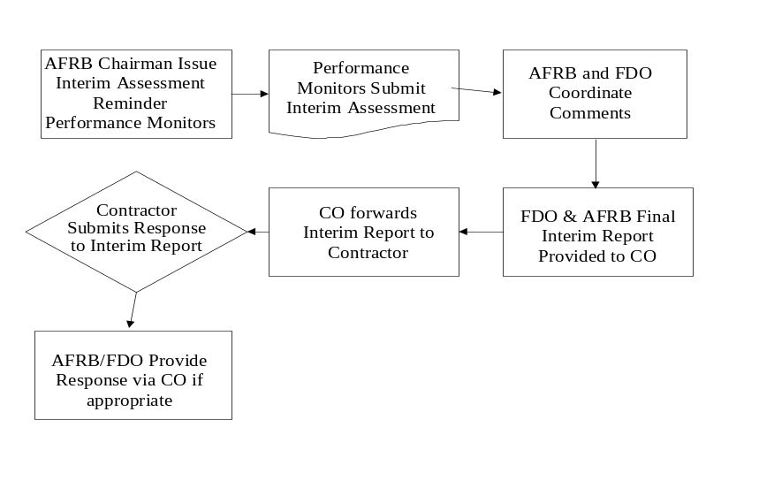
Figure 4 -- Interim Assessment Process
The AFRB Chairman notifies Performance Monitors in sufficient time before the mid-point of the evaluation period (e.g., 14 calendar days) to submit their interim evaluations. Performance Monitors annotate areas where they feel improvements in the contractor’s performance are expected or required. They should also annotate areas of strength. Performance Monitors’ interim evaluations are consolidated by the Recorder and presented to the Board. The consolidated mid-term evaluation should be documented in narrative or briefing format and should involve the FDO prior to distributing it to the contractor under separate cover letter from the CO.

The interim evaluation provided to the contractor should not contain any fee determination or rating. It should address the strengths and weaknesses noted for the current evaluation period. A written interim evaluation ensures that the contractor is informed of areas where corrective action(s) can be taken in sufficient time to correct these deficiencies prior to the FDO’s award-fee amount determination. When deemed necessary, additional letters may be sent to the contractor identifying areas of concern. These documents should be sent under separate cover letter by the CO to the contractor’s contracting officer. The contractor’s response, if required, should include plans for increasing effectiveness in the areas for improvements and is submitted to the CO.
As part of the interim evaluation, Performance Monitors and the Review Board assess the upcoming requirements and recommend any significant changes to the plan to the FDO. The award-fee plan may be modified at any point during the length of the contract. However, changes to the current evaluation period must be made by mutual agreement of the parties. Unilateral changes may be made before the start of the effected evaluation period.

7.3 -- End-of-Period Evaluation Process

7.3.1 -- Award Fee

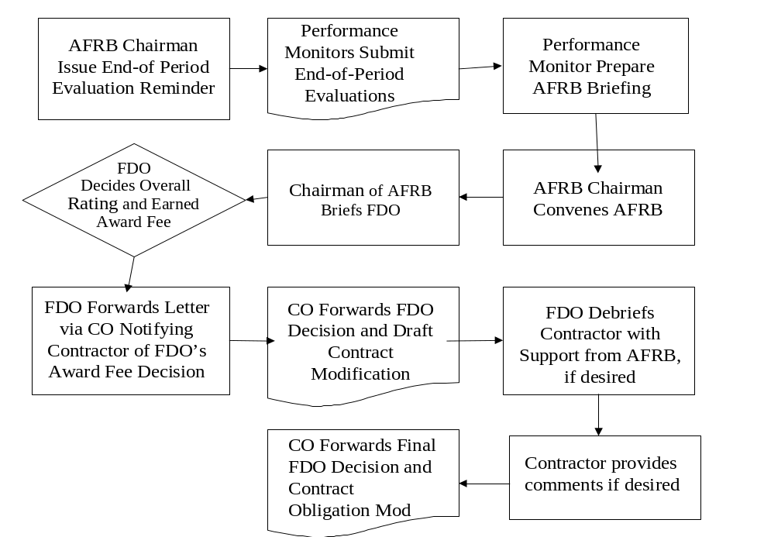
Figure 5 – End-of-Period Evaluation Process

The AFRB Chairman notifies Performance Monitors in sufficient time before the end of the evaluation period (e.g., 14 calendar days) to submit their evaluations. Upon receipt of the Performance Monitors’ evaluations, the Recorder consolidates a summary evaluation and provides it to the AFRB. Where desired, Performance Monitors can brief in person, the Performance Monitor should provide an advanced copy of charts and comments so the AFRB can discuss the evaluation competently during the evaluation. The CO with the recommendation of the AFRB and the approval of the FDO may also send a copy of the summary evaluation to the contractor in order to provide the contractor an opportunity to review and comment on the evaluation. The summary evaluation provided to the contractor should not include an actual rating or grade. The summary evaluation may be in a narrative or briefing format. The contractor may also submit a self-evaluation of its performance for that period. The self-evaluation may be a written assessment submitted to the CO or a presentation to the AFRB. If the contractor desires to make a presentation, he should notify the CO within 10 days prior to the end of the evaluation period. The AFRB evaluates the findings; contractor’s self-assessment, if submitted; and other pertinent information to develop a recommended earned award-fee amount for the FDO. The AFRB may desire to have a contractor representative available after the Performance Monitors’ evaluation to answer any questions that arise during the evaluation process.
The Chairperson briefs the FDO on the AFRB’s recommendations of the earned award-fee amount and any significant changes to the award-fee plan. The briefing includes discussion of the contractor’s related strengths and weaknesses. The FDO may consider allowing the contractor to attend this briefing and present comments in which case the CO must be in attendance, but the contractor should not be allowed to participate in the final decision-making. If the contractor does not attend the FDO briefing, a debriefing of the contractor may be considered to enhance communication.
After the FDO decides an overall rating and the award-fee amount for the evaluation period, a FDO determination letter is sent to the contractor via cover letter from the CO. The determination letter should be clear and concise, informing the contractor of the earned-award-fee amount and the major strengths and weaknesses of the contractor for that award-fee evaluation period. The CO should issue within 15 calendar days after the FDO’s determination, a unilateral contract modification to authorize payment of the earned-award-fee amount., The CO should de-commit or de-obligate, as appropriate, all unearned award fee for that evaluation period unless a rollover has been authorized.

7.4 -- Delivery or Task Order Contracts Evaluated at the Contract-Level
In many cases the Government wants to motivate the contractor’s performance at the contract level versus each individual order. This condition may exist when the overriding objective is not how each individual order is executed, but how the contractor’s performance of multiple orders contributes to meeting the overall contract objectives. For example, a weapon system program’s Producibility Enhancement/Performance Enhancement contract, which begins with a series of known requirements as well as currently unknown/undefined requirements that may materialize during the contract. An unknown requirement may arise that has a higher priority than an existing order. The primary objective is for the Government/contractor team to make trade-offs between the orders in a constrained environment (contract dollars, hours, etc.) to ensure the optimal capability is achieved at the system performance level. Therefore, the ultimate measure of success is judged as meeting the overall contract objectives and not necessarily on the performance of a single order. In this case, it is in the Government’s best interest to incentivize the contractor to focus its efforts and perspective on overall contract performance versus the individual orders. The key to successful implementation of this approach is for the Performance Monitors, AFRB and FDO to ensure the integrity of the award-fee plan by maintaining this higher-level perspective on the overall contract performance rather than on individual orders during the evaluation process.

7.4.1 -- Orders with the Same Type of Funds
If orders are placed and funded with the same type of funds, the contract objectives and evaluation criteria can be established in the award-fee plan at the overall contract level. If the award-fee plan does this, then the available award fee for each evaluation period may be established at the total contract level. At the end of the award-fee evaluation period, the contractor’s performance in achieving the overall contract objectives may be evaluated using the award-fee plan criteria. The FDO decision of earned award fee is also made at the contract level. The earned-award-fee amount is subsequently obligated against the ACRN that funds the overall contract.
 | Order A | Order B | Order C | Contract Total
Funding | $10,000 | $50,000 | $40,000 | $100,000
Available Award Fee (10%) |  |  |  | $10,000
Earned Award Fee (80%) |  |  |  | $8,000

7.4.2 -- Orders with Different Types of Funds
If the orders placed on contract are funded with different appropriations or are for different customers’ requirements, the contractor’s performance may still be evaluated at the contract level. Remember, it is important that the award-fee plan focuses the evaluation process on achieving the overall contract objectives and not only on accomplishing individual orders. In this type of contract situation where each task brings with it separate and discrete funding for its requirements, maintaining the fiscal integrity of the available award fee and final allocation to the tasks on the contract is very important! Fiscal integrity can be accomplished by a meaningful, proportional relationship of the individual orders to the overall contract performance objectives. This can take the form of order funding (see example below), required contract hours, or some other logical method. The total available award fee for the evaluation period is calculated by applying a consistent methodology to each order. Using the same relationship consistently, the FDO-determined earned award-fee amount is then allocated back to each order to determine the amounts of each appropriation to be obligated. (Note: Orders funded by the same appropriation can be mathematically aggregated for ease of administration when contracts involve a significant number of orders.)

 |  | Contract Funding | Available Award Fee (10%) | Earned Award Fee (80 %)
 | First Appropriation | $10,000 | $1,000 | $800
 | Second Appropriation | $50,000 | $5,000 | $4,000
 | Third Appropriation | $40,000 | $4,000 | $3,200
 | Total Contract Funding | $100,000 | $10,000 | $8,000

If the earned award-fee determination is based on the contractor’s performance in achieving the overall contract objective and not against individual orders, it is inappropriate to establish the available-award-fee amount or apply the earned-award-fee amount to the individual orders. Likewise, if the earned award-fee determination is based on the contractor’s performance in completing the individual orders, it is inappropriate to establish the available-award-fee amount or apply the earned-award-fee amount to the overall contract.
This aggregated-award-fee-evaluation process can lead to special concerns for maintaining fiscal integrity, especially when multiple types of funds or various customers are involved. Consequently, when using this approach, the following minimum criteria must be used to avoid the inherent risks.
1. The award-fee plan should clearly state that the evaluation criteria are applicable at the contract level and not to each individual order placed on the contract. This does not preclude management of individual orders (e.g., discussions with the contractor in the fulfillment of each order). But, the award-fee plan should clearly communicate that the contractor earns award fee based on how the accomplishment of each order contributed to the overall contract objectives. For example, a contract is negotiated to increase the useful military life of a given weapon system through the development of engineering changes to specific subsystems or components. If each specific subsystem or component changes were separate orders, the evaluation criteria should clearly promote the overall weapon system’s increased life and not the increased life provided by each subsystem or component engineering change. If the criteria focused on increased life to the weapon system based on changes to the subsystem or component, the criteria would be too narrowly focused to allow for evaluation at the contract level. Therefore, it would be inappropriate to evaluate the contractor’s performance and allocate the funds at the contract level.
2. A second concern may arise when a contract serves multiple customers’ requirements with competing priorities. This may result in a customer believing that his particular requirement was not fully satisfied. This can result in an award-fee evaluation input that reflects individual order performance rather than meeting overall contract objectives. Although avoiding this situation can present a real dilemma in a customer-oriented quality culture, the AFRB must remain focused on how well the contractor optimized the available resources to maximize the delivered value. Understanding the trade-offs exercised during the performance of the contract can be integral in evaluating the degree in which overall contract objectives were achieved.

3. Use caution to prevent having a contract that incentivizes performance of orders rather than meeting overall contract objectives. This occurs when each order is actually being separately evaluated using the evaluation criteria and subsequently assigned an individual “score,” which is then aggregated with the scores of the other orders to determine an overall average award-fee determination. It also occurs when the FDO makes an award-fee determination that is allocated based on contractor performance against the individual orders. Claiming that the earned award fee is based on overall contract performance is misleading, not appropriate and may result in audit scrutiny.
When using this type of award-fee structure with multiple funding sources, fiscal integrity must be maintained. Each order placed on the contract must bear a logical and proportionate burden of the available-award-fee amount. In calculating the allocation of the earned-award-fee, you must maintain the same logical and proportional relationship as used for establishing the available award-fee amount. This is an area subject to audit scrutiny or potential fiscal improprieties if not properly managed.

7.5 -- Delivery or Task Order Award-Fee Contracts Evaluated at Order-Level
The basic award-fee process is similar for delivery or task order contracts. The increasing use of these contracts for ordering supplies and services using various funds poses additional challenges to fiscal integrity. To the extent that these contracts allow the placement of specific requirements on orders that are independent of other orders’ requirements and with separate, distinct sources of funding, the evaluation of performance and the funding of the award fee should be directed to evaluating the contractor’s performance on each order against the award-fee criteria on a task-by-task basis. The earned-award-fee amount would then be specific to each order and ensures it matches the funds used on the associated effort. The fiscal principles that must be observed are relatively inflexible. Since the award-fee funds must match the appropriation that funded performance of the work, the commingling of funds from multiple fiscal years or different appropriations must be avoided, wherever possible. (For more information on fiscal issues, see Chapter 4, Funding.)

Appendix A
Evaluation Process Flowcharts
AWARD FEE PLAN DEVELOPMENT
TRAINING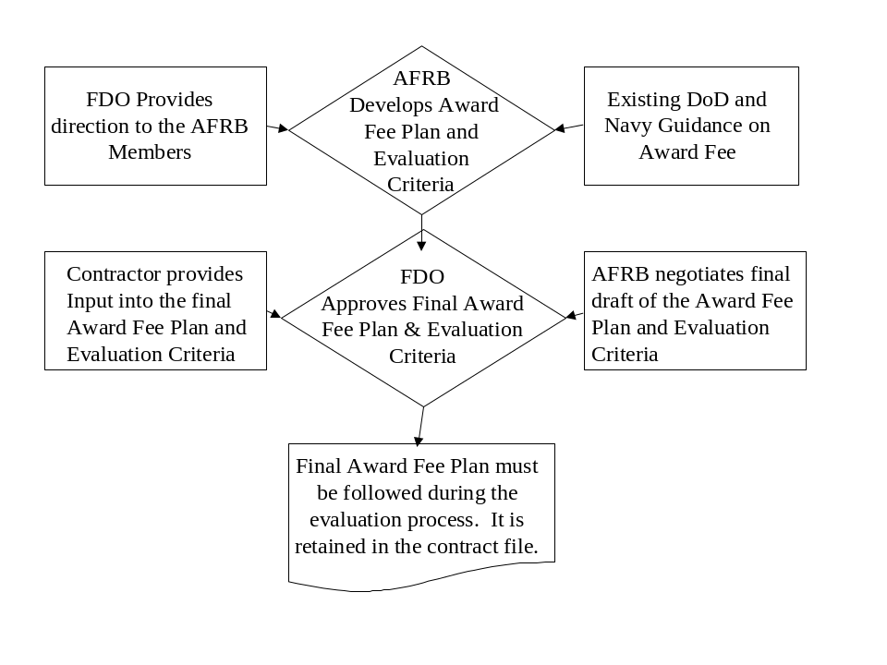

Figure 9 -- Evaluation Process Flowcharts (Award Fee Plan Development and Training)

INTERIM
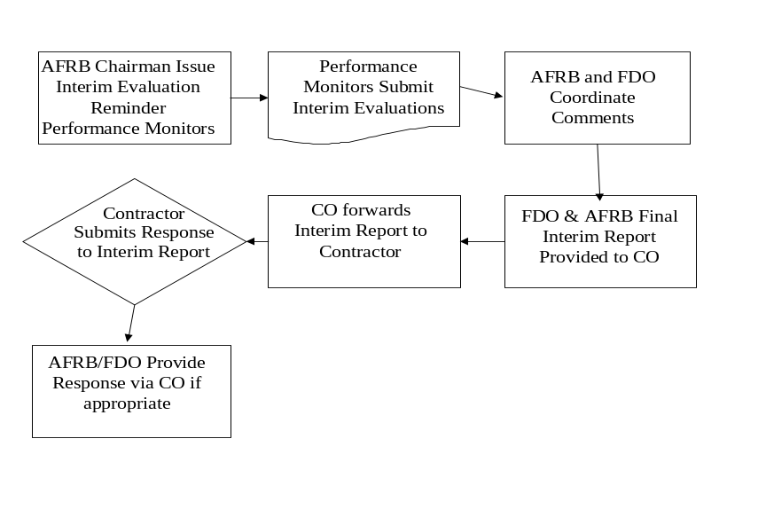
END OF PERIOD AWARD FEE
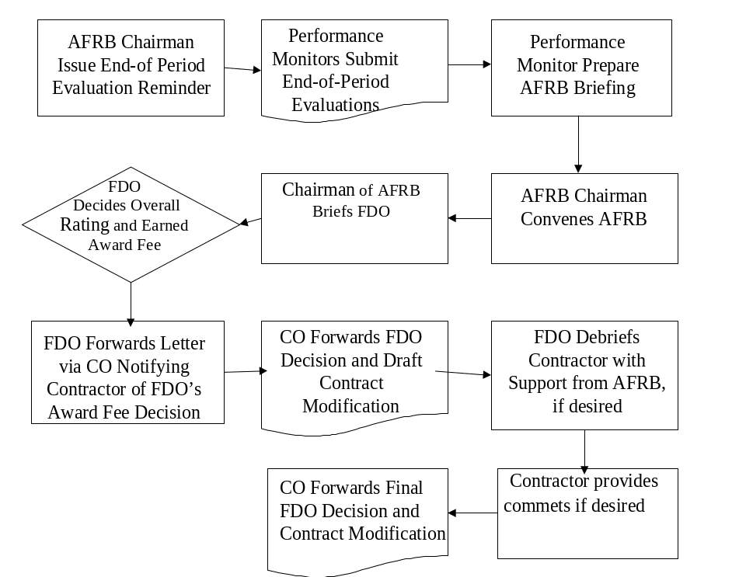

Figure 10 -- Evaluation Process Flowcharts (Interim and End of Period Award Fee)

Appendix B

Checklists
B.1

Pre-Award-Fee Plan: As a minimum:
Appoint FDO by position
Identify Members of the AFRB by position
Identify Performance Monitors by Function
Define Requirement
Define Areas for which Award Fee is to be given
Describe Categories of Performance (e.g., Technical, Cost Control)
Determine where Emphasis should lie
Discuss and arrive at Evaluation Criteria
Determine Evaluation Periods by Date or Milestone and Anticipated Milestone Completion Date
Estimate Allocation of Funds by Dollar Amount or Percentage of Available Award Fee by Evaluation Period
Discuss evaluation process
Determine need for Rollover of Fee
Draft General Procedures for AFRB
General:

Award-Fee Plan: As a minimum:
Identify FDO by position
Identify Members of the AFRB by position
Identify Performance Monitors by Function
Define Grades used to Measure Contractor’s Performance
Define Categories of Performance (e.g., Technical, Cost Control)
Specify Weights, if applicable
Define the Evaluation Criteria (e.g., What constitutes Excellent Performance Cost Control?)
List Evaluation Periods by Date or Milestone and Anticipated Milestone Completion Date
List Allocation of Funds by Dollar Amount or Percentage of Available Award Fee by Evaluation Period
Establish Scoring Mechanism, if applicable
Address Interim Evaluations, if applicable
Set up General Procedures for AFRB
General:
Incorporate Award-fee Plan in the Draft RFP
Include draft clause in RFP
Incorporate Award-fee Plan in the Final RFP
Train all personnel involved in the award-fee process
Document Justification for Rollover in Official Contract File
Document FDO Determination in Official Contract File
Contract Clause: Include completed clause, “Award Fee,” in Section H of the Contract

Appendix C
Award-Fee Plan Template

(Fill-in information is shown in bold Italics.)
(Text shown in Italics provides additional guidance/information)
Award-Fee Plan
For
(Title Of Program)
(Date Of Approval)
(Contractor’s Name)
(Remember, this plan should be tailored to your particular acquisition.
This template only provides an outline of what should be contained
in an award-fee plan.)
Approved:
_______________________
Fee Determining Official
(Title)
Table of Contents
Section | Title | Page
1.0 | Introduction | XX
2.0 | Organization | XX
3.0 | Responsibilities | XX
4.0 | Award-Fee Processes | XX
5.0 | Award-Fee Plan Change Procedure | XX
6.0 | Contract Termination | XX
Annexes
Annex | Title | Page
1 | Award-fee Organization | XX
2 | Award-Fee Allocation by Evaluation Periods | XX
3 | Evaluation Criteria | XX

Award-Fee Plan

1.0 -- Introduction
This award-fee plan is the basis for the (title of the program) evaluation of the contractor’s performance and for presenting an assessment of that performance to the Fee Determining Official (FDO). It describes specific criteria and procedures used to assess the contractor’s performance and to determine the amount of award fee earned. Actual award-fee determinations and the methodology for determining award fee are unilateral decisions made solely at the discretion of the Government, although the determination is subject to the Disputes clause.
The award fee will be provided to the contractor through contract modifications and is in addition to the (type contract) provisions of the contract. The award fee earned and payable will be determined by the FDO based upon review of the contractor’s performance against the criteria set forth in this plan. The FDO may unilaterally change this plan prior to the beginning of an evaluation period. The contractor will be notified of changes to the plan by the Contracting Officer, in writing, before the start of the affected evaluation period. Changes to this plan that are applicable to a current evaluation period will be incorporated by mutual consent of both parties.

2.0 -- Organization
The award-fee organization consists of the Fee Determining Official (FDO); an Award Fee Review Board (AFRB) which consists of a chairperson, the contracting officer, a recorder, other functional area participants, and advisor members; and the Performance Monitors. (Remember, performance monitors are prohibited from being AFRB members.) The FDO, AFRB members, and performance monitors are listed in Annex 1. (If you prefer, you can insert the lists here rather than using an annex).

3.0 -- Responsibilities
a. Fee Determining Official. The FDO approves the award-fee plan and any significant changes. The FDO reviews the recommendation(s) of the AFRB, considers all pertinent data, and determines the earned award-fee amount for each evaluation period.
b. Award Fee Review Board. AFRB members review Performance Monitors’ evaluation of the contractor’s performance, consider all information from pertinent sources, prepare interim performance reports, and arrive at an earned award-fee recommendation to be presented to the FDO. The AFRB may also recommend changes to this plan.
c. Chairman Award Fee Review Board. Chairman AFRB is responsible for the overall functioning of the AFRB in the performance of its members.
- schedule all meetings of the AFRB and notifying its members of the meetings;
- conducting the briefing of the FDO with regard to the recommendations of the AFRB.

d. AFRB Recorder. The AFRB recorder is responsible for coordinating the administrative actions required by the Performance Monitors, the AFRB and the FDO, including:
(l) maintaining records of all meetings in developing the award fee plan including documenting all meetings and reasoning for developing the plan as established ( a copy of which will be provided to the CO for retention in the contract file);
(2) receipt, processing and distribution of evaluation reports from all required sources;
(3) scheduling and assisting with internal evaluation milestones, such as briefings; and
(4) accomplishing other actions required to ensure the smooth operation of the award fee.
e. Contracting Officer (CO). The CO is the liaison between contractor and Government personnel on all issues, forwarding FDO decision with regard to the Award Fee Determination and maintaining the contract file.
f. Performance Monitors. Performance Monitors maintain written records of the contractor’s performance in their assigned evaluation area(s) so that a fair and accurate evaluation is obtained. Prepare interim and end-of-period evaluation reports as directed by the AFRB.

4.0 -- Award-Fee Processes
(Detail the process used for your acquisition; e.g., interim evaluation periods may or may not be in your acquisition; you have some flexibility in establishing the timetable for certain events; contractor’s self-assessments may or may not be used, etc.)
a. Available. Award-Fee Amount. The available award fee for each evaluation period is shown in Annex 2. The award fee earned will be paid based on the contractor’s performance during each evaluation period. (If you don’t want to use an annex, insert table/graph/etc. for guidance in determining the relationship between evaluation points and various grades here.)
b. Evaluation Criteria. If the CO does not give specific notice in writing to the contractor of any change to the evaluation criteria prior to the start of a new evaluation period, then the same criteria listed for the preceding period will be used in the subsequent award-fee evaluation period. Any changes to evaluation criteria will be made by revising Annex 3 and notifying the contractor.
c. Interim Evaluation Process. The AFRB Recorder notifies each AFRB member and Performance Monitor (insert number of days) calendar days before the midpoint of the evaluation period. Performance Monitors submit their evaluation reports to the AFRB (insert number of days) calendar days after this notification. The AFRB determines the interim evaluation results and notifies the contractor of the strength and weaknesses for the current evaluation period. The CO may also issue letters at any other time when it is deemed necessary to highlight areas of Government concern.
d. End-of-Period Evaluations. The AFRB Recorder notifies each AFRB member and performance monitor (insert number of days) calendar days before the end of the evaluation period. Performance monitors submit their evaluation reports to the AFRB (insert number of days) calendar days after the end of the evaluation period. The AFRB prepares its evaluation report and recommendation of earned award fee. The AFRB briefs the evaluation report and recommendation to the FDO. At this time, the AFRB may also recommend any significant changes to the award-fee plan for FDO approval. The FDO determines the overall grade and earned award-fee amount for the evaluation period within (insert number of days, but no more than 45) calendar days after each evaluation period. The FDO letter informs the contractor of the earned award-fee amount, which will be forwarded to the contractor under a CO cover letter. The CO issues a contract modification within (insert number of days, but no more than 15) calendar days after the FDO’s decision is made authorizing payment of the earned-award-fee amount.
e. Contractor’s Self-Assessment. When the contractor chooses to submit a self-evaluation, it must be submitted to the CO within five working days of the closure of the evaluation period. This written assessment of the contractor’s performance throughout the evaluation period may also contain any information that may be reasonably expected to assist the AFRB in evaluating the contractor’s performance. The contractor’s self-assessment may not exceed (insert number of pages, make sure it matches the number in the contract clause) pages.

5.0 -- Award-Fee Plan Change Procedure
All significant changes are approved by the FDO; the AFRB Chairperson approves other changes. Examples of significant changes include changing evaluation criteria, adjusting weights to redirect contractor’s emphasis to areas needing improvement, and revising the distribution of the award-fee dollars. The contractor may recommend changes to the CO no later than (insert number of days) days prior to the beginning of the new evaluation period. After approval, the CO shall notify the contractor in writing of any change(s). Unilateral changes may be made to the award-fee plan if the contractor is provided written notification by the contracting officer (insert number of days) before the start of the upcoming evaluation period. Changes effecting the current evaluation period must be by mutual agreement of both parties.

6.0 -- Contract Termination
If the contract is terminated for the convenience of the Government after the start of an award-fee evaluation period, the award fee deemed earned for that period shall be determined by the FDO using the normal award-fee evaluation process. After termination for convenience, the remaining award-fee amounts allocated to all subsequent award-fee evaluation periods cannot be earned by the contractor and, therefore, shall not be paid.
3 Annexes
1. Award-fee Organization by position
2. Award-Fee Allocation by Evaluation Periods
3. Evaluation Criteria
Annex 1 -- Award-Fee Organization
Members
Fee Determining Official: (Position Title) |  | (Office Code)
Award Fee Review Board Chairperson: (Position Title) |  | (Office Code)
Award Fee Review Board Members:
 | Deputy Program Director | (Office Code)
 | Program Manager | (Office Code)
 | Contracting Officer* | (Office Code)
 | Recorder* | (Office Code)
(Following are other possible members:)
 | Contracting Staff Member | (Office Code)
 | Judge Advocate Staff Member | (Office Code)
 | Financial Management Staff Member | (Office Code)
 | Plans Staff Member | (Office Code)
Representative for Logistics |  | (Office Code)
Representative for Engineering |  | (Office Code)
Senior Contracting Official |  | (Office Code)
Representative for Configuration and Data |  | (Office Code)
Representative for Program Control or Oversite |  | (Office Code)
 | DCMA or Administration representative | (Office Code)

* These are mandatory members.
Performance Monitors
(Select your monitors based on the needs of your acquisition)
 | Area of Evaluation | Performance Monitor(s)
 | Program Management | (Office Code)
 | Subcontract Management | (Office Code)
 | Manufacturing Management | (Office Code)
 | Quality Assurance | (Office Code)
 | Configuration Management | (Office Code)
 | Engineering and Test Management | (Office Code)
 | Cost and Schedule Management | (Office Code)
 | Logistics | (Office Code)
 | Technical Orders | (Office Code)

Annex 2 -- Award-Fee Allocation by Evaluation Periods
The award fee earned by the contractor will be determined at the completion of evaluation periods shown below. The percentage and dollars shown corresponding to each period is the maximum available-award-fee amount that can be earned during that particular period. (Fill in table specific to your acquisition).
 | Evaluation Period * | From | To | Available Award Fee **
 | First
 | through
 | Last period
 |  |  | Total | 100%

(If you use milestones, include expected milestone completion dates. Use a table similar to the one below).
 | Evaluation Period * | Milestone | Expected Completion Date | Available Award Fee **
 | First
 | through
 | Last period
 |  |  |  | 100%

* The Government may unilaterally revise the distribution of the remaining award-fee dollars among subsequent periods. The contractor will be notified of such changes, if any, in writing by the CO before the relevant period is started and the award-fee plan will be modified accordingly. Subsequent to the commencement of a period, changes to that period may only be made by mutual agreement of the parties.
** Will be computed in and expressed in dollars at conclusion of negotiations (for sole source) or in proposal and Final Price Revision (for competition) using percentage shown.
Annex 3 -- Evaluation Criteria
(See Annex E, Samples Award-Fee Plan Criteria, for examples.)
(List the evaluation criteria for each category of performance by grade. In other words, tell what constitutes Excellent versus Satisfactory versus Unsatisfactory performance for Program Management, Cost Control, etc.)
Cost Management
Unsatisfactory -- Contractor fails to meet criteria for Satisfactory performance.
Satisfactory | Good | Very Good | Excellent
Cost Control -- Provides measures for controlling costs. Controls subcontractor cost performance to meet program objectives. Funds and resources are sometimes used inefficiently in pursuing program goals. Occasional minor resource management problems. | Cost Control – Provides a measure for controlling all costs at or slightly below contract-estimated costs. Provides good cost control of all costs during contract performance. Funds and resources are generally used in a cost-effective manner. No major resource management problems apparent. | Cost Control -- Provides measures for controlling all costs below contract-estimated costs. Considers logistic and long-term costs in recommendations to the Program Office. Funds and resources are always used in a cost-effective manner. No resource management problems. | Cost Control -- Reductions in direct costs to the Government below contract estimated costs are noteworthy. Provides detailed cost analysis in recommendations to Program Office for resolution to problems identified. Funds and resources are optimally used to provide the maximum benefit for the funds and resources available. Documented savings are apparent.
Responsiveness -- Financial reporting is accurate. Provides adequate visibility into cost performance to Program Office. Problems and/or trends are usually addressed. When provided, analyses of problems and trends are adequate. | Responsiveness – Financial reporting is clear and adequate. Takes the initiative to reduce costs, where feasible. Provides adequate visibility into cost performance to Program Office. Problems and/or trends are always addressed and analyses are also submitted. The analyses provide good insight to the Government. | Responsiveness -- Financial reporting is clear and adequate. Provides very good day-to-day visibility into cost performance to Program Office. Problems and/or trends are addressed thoroughly and analyses provide recommendations for solutions and/or corrective action plans. | Responsiveness -- Financial reporting is clear, accurate, and pro-active. Responsive to cost-control measures implemented by the Program Office. Problems and/or trends are not only addressed thoroughly, but the contractor’s recommendations and/or corrective action plans are implemented and are effective.

Appendix D
Sample Grade Definitions
Note: Grades need to be identified in the Award-Fee Plan. These definitions are provided to assist you in establishing evaluation criteria. The description of what constitutes each level of performance within each performance category must be included in an annex.
For Five Grades
Unsatisfactory Performance: Contractor’s performance of most contract tasks is inadequate and inconsistent. Quality, responsiveness, and timeliness in many areas require attention and action. Corrective actions have not been taken or are ineffective. Overall unsatisfactory performance shall not earn an award fee.
Satisfactory Performance: Contractor’s performance of most contract tasks is adequate with few tangible benefits to the Government due to contractor’s effort or initiative. Although there are areas of good or better performance, these are more or less offset by lower-rated performance in other areas.
Good Performance: Contractor’s performance of most contract tasks is better than adequate and provides some tangible benefits to the Government in several significant areas. While the remainder of the contractor’s effort generally meets the contract requirements, areas requiring improvement are more than offset by better performance in other areas.
Very Good Performance: Contractor’s performance of most contract tasks is consistently above standard and provides numerous significant tangible and intangible benefits to the Government (e.g., improved quality, responsiveness, increased timeliness, or generally enhanced effectiveness of operations). Although some areas may require improvement; these areas are minor and are more than offset by better performance in other areas. Few, if any, recurring problems have been noted, and contractor takes satisfactory corrective action.
Excellent Performance: Contractor’s performance of virtually all contract tasks is consistently noteworthy and provides numerous significant, tangible or intangible, benefits to the Government. The few areas for improvement are all minor. There are no recurring problems. Contractor’s management initiates effective corrective action whenever needed.
For Four Grades
Unsatisfactory Performance: Contractor’s performance of most contract tasks is inadequate and inconsistent. Quality, responsiveness, and timeliness in many areas require attention and action. Corrective actions have not been taken or are ineffective. Overall unsatisfactory performance shall not earn an award fee.
Satisfactory Performance: Contractor’s performance of most contract tasks is adequate with some tangible benefits to the Government due to contractor’s effort or initiative. Although there are areas of good or better performance, these are more or less offset by lower-rated performance in other areas.
Very Good Performance: Contractor’s performance of most contract tasks is consistently above standard and provides significant tangible and intangible benefits to the Government (e.g., improved quality, responsiveness, increased timeliness, or generally enhanced effectiveness of operations). Although some areas may require improvement; these areas are minor and are more than offset by better performance in other areas. Few, if any, recurring problems have been noted, and contractor takes satisfactory corrective action.
Excellent Performance: Contractor’s performance of virtually all contract tasks is consistently noteworthy and provides numerous significant, tangible or intangible, benefits to the Government. The few areas for improvement are all minor. There are no recurring problems. Contractor’s management initiates effective corrective action whenever needed.
For Three Grades
Unsatisfactory Performance: Contractor’s performance of most contract tasks is inadequate and inconsistent. Quality, responsiveness, and timeliness in many areas require attention and action. Corrective actions have not been taken or are ineffective. Overall unsatisfactory performance shall not earn an award fee.
Satisfactory Performance: Contractor’s performance of most contract tasks is adequate with some tangible and intangible benefits to the Government due to contractor’s effort or initiative. Although there are areas of better performance, these are more or less offset by lower-rated performance in other areas.
Excellent Performance: Contractor’s performance of virtually all contract tasks is consistently noteworthy and provides numerous significant, tangible or intangible, benefits to the Government (e.g., improved quality, responsiveness, increased timeliness, or generally enhanced effectiveness of operations). The few areas for improvement are all minor. There are no recurring problems. Contractor’s management initiates effective corrective action whenever needed.

Appendix E

Sample Evaluation Criteria
This appendix contains 12 samples of evaluation criteria for various categories of performance. There are four samples for the basic performance category of cost to show the variety of criteria that can be used. Tailor the criteria for each performance category based on your acquisition.
A Performance Assessment Matrix Template is also provided. The template demonstrates how to develop objective measurement to support the subjective evaluation process.
The 12 performance categories, with number of grades in parentheses, are listed below. The page numbers on which they can be found are also listed.
Performance Category |  | Grades |  | On Page
 | COST AND SCHEDULE MANAGEMENT |  | 5 |  | XX
 | COST CONTROL |  | 5 |  | XX
 | COST CONTROL/REPORTING  (In table format) |  | 3 |  | XX
 | COST PERFORMANCE  (In table format) |  | 4 |  | XX
 | ORGANIZATION AND MANAGEMENT  (In table format) |  | 3 |  | XX
 | PROGRAM MANAGEMENT |  | 5 |  | XX
 | QUALITY ASSURANCE |  | 5 |  | XX
 | QUALITY OF WORK |  | 5 |  | XX
 | PRODUCT QUALITY |  | 3 |  | XX
 | TECHNICAL PERFORMANCE |  | 3 |  | XX
 | TIME OF DELIVERY |  | 5 |  | XX
 | SCHEDULE |  | 3 |  | XX
 | PERFORMANCE ASSESSMENT MATRIX TEMPLATE |  | 5 |  | XX

Cost and Schedule Management
Unsatisfactory
1. Cost and schedule reports are unclear and not easily reconcilable to a common database.
2. Funds requirements data are not received timely.
3. Cost and schedule variances (including subcontractor) are not identified early.
4. Contractor does not ensure all proposal data, including subcontractor data, is adequate for technical review and cost analysis.
5. Contractor does not meet schedule identified in the contract.
Satisfactory
1. All cost and schedule reports are clear and reconcile to a common database.
2. Funds requirements data are projected accurately and clearly and are received timely.
3. Cost and schedule variances (including subcontractor) are identified early and plans for recovery revised, reported, and implemented.
4. Contractor ensures all proposal data, including subcontractor data, is adequate for technical review and cost analysis.
5. Changes are suggested timely to achieve maximum cost savings when implemented.
6. Schedule milestone tracking and projections are accurate with only minor impacts occurring.
7. Contractor meets schedule identified in the contract.
Good
1. Cost reports are submitted with full traceability within and between reports. Adjustments are fully and clearly explained.
2. All requirements for additional funding are thoroughly documented and justified.
3. Contractor takes measures to avoid cost growth. Corrective actions are briefed to the Government and are generally accepted without changes.
4. Cost data is consistent and logical and based on program requirements. Contractor recognizes where cost growth may be occurring and provides timely and well-documented justification of actual problems that would require application of additional resources.
5. Cost proposals are well organized and provide visibility to the Government.
6. Risk analyses of all proposed or required schedule changes, including the impact on all levels of the program, performed accurately and timely. Contractor employs early corrective action and planning to preclude potential delays in the schedule. Contractor communicates schedule risk areas and proposed action to the Government well in advance of required action.
7. Contractor plans, develops and executes procedures that meet the existing timetable.
Very Good
1. Funds requirements reflect constant scrutiny to ensure accuracy.
2. Cost savings are considered and reported in change proposals.
3. Contractor prepares and develops graphic program cost and schedule data that provides clear Government visibility into current and forecast program costs and schedules. Variances recovered without serious impact to technical or schedule goals when recovery plans are implemented. Schedule variances are well explained and recovered with minor impact to overall program goals.
4. Contractor performs necessary contingency planning and keeps close and timely communication with the Government on cost and schedule issues.
5. Baseline integrity is consistently maintained, and all changes are fully documented. Narratives explaining data variances (cost/schedule at completion) are current, explicit, and relevant to the variances observed. They are fully accurate and a consistent indication of the program development. Narratives address anticipated future program impacts and fully describe both current and future programmatic and cost impacts of the current cost/schedule performance.
6. Schedule milestone tracking and projections are very accurate and reflect true program status.
7. Plans, develops and executes viable procedures that incorporate the flexibility necessary to be responsive to changing priorities and schedules without adversely effecting overall system cost and completion schedule. Contractor executes innovative resource management and planning to minimize the adverse impact on the program of any scheduled slip.
8. Contractor is ahead of schedule with no adverse effect on cost or performance.
Excellent
1. Contractor consistently submits high quality cost and schedule forecasts. Contractor prepares and develops comprehensive, clear schedule data that provides excellent correlation with cost performance reports and permits early identification of problem areas.
2. Funds requirements data and projections reported are extremely accurate and received ahead of schedule.
3. Change proposals stand-alone and require no iteration for Government understanding.
4. Cost variances are fully explained and recovered without impact to overall program goals.
5. Contractor consistently anticipates possible sources of cost growth and seeks ways to avoid potential cost problems. Contractor proposes innovative and thoroughly cost-effective approaches to problems with which the Government agrees.
6. Cost management system automatically identifies problem areas and implements solutions to maintain cost and staff growth levels below the negotiated levels. No support or redirection required by the Government to control cost growth.
7. Contractor plans, develops and executes procedures that allow completion of major milestones ahead of schedule with no adverse impact on coordination, performance or cost and which cause the accrual of benefits to the program.
8. Schedule milestone tracking and projections are extremely accurate and prevent program impact.
Cost Control
Unsatisfactory
1. Contractor’s planning for staff utilization goals left up to designers on drafting board.
2. Contractor does not control expenditures for direct charges (i.e., services).
3. Contractor does not meet cost estimate for original work or changes 30% of the time.
Satisfactory
1. Contractor’s management sets and reviews staff utilization goals.
2. Contractor’s management occasionally reviews expenditures for control direct charges (i.e., services).
3. Contractor does not meet cost estimate for original work or changes 20% of the time.
Good
1. Contractor’s management sets staff utilization goals by system planning that are reviewed by engineering.
2. Contractor sets direct charges (i.e., services) and accounts for them on each work package.
3. Contractor exceeds original estimate on change orders 10% of the time and meets original design costs.

Very Good
1. Contractor’s system engineers establish design parameters that are held in design plans.
2. Contractor provides services as part of normal design function without extra charges.
3. Contractor exceeds original estimate on change orders 5% of the time and meets original design costs.
Excellent
1. Contractor limits modifications to the design plan to less than 5% that result from lack of engineering system correlation.
2. No cost overruns on original estimates.
3. Contractor never exceeds original estimate on original design package or change orders.
Cost Control and Reporting
Unsatisfactory | Satisfactory | Excellent
The contractor does not have an adequate cost control program in place and is unable to reduce cost impact resulting from schedule delays. Additionally, the contractor fails to identify problem areas. | A cost control program is in place that provides a mechanism to reduce the overall cost of the program. | The contractor has clear understanding of the need to maintain cost control and actively pursues cost containment and reduction through innovative approaches and superior management of resources.
When problems are discovered, the contractor often fails to take actions to minimize cost/schedule impacts or to notify the Government of the situations. As a result of the contractor’s inaction, the program experiences cost/schedule impacts. | The contractor recognizes and timely advises of problem areas and assists the Navy in implementing corrective action to reduce cost. Resources are utilized to ensure that contract performance results in completion with minimal schedule disruption and impact to overall program cost. | The contractor is proactive in assisting the Navy with problem identification. Potential problems are identified, and corrective action is implemented to minimize cost/schedule impacts. The Government is notified immediately of significant problems and the contractor interacts with the Government to develop viable resolutions and overcome delays without additional cost.
Cost proposals are not traceable, and the proposals typically do not contain sufficient detail to support a thorough cost analysis. Basis of estimates for cost elements and detailed analyses for subcontractor costs are sometimes missing. The contractor is uncooperative regarding Government requests for missing information. | Cost proposals are traceable and the proposals customarily contain sufficient detail to support a thorough cost analysis. Bases of estimates are provided for cost elements and detailed analyses are regularly provided for subcontractor costs. When insufficient detail exists, the contractor readily provides it to the Government upon request. | Cost proposals are timely, well constructed, and contain sufficient detail to support an in-depth cost analysis. The bases of estimates are provided for all cost elements and detailed analyses are provided for subcontractor costs.
Cost data reports are continually late, frequently incomplete, or incorrect and do not provide an accurate overview of overall contract cost. Contract administration and oversight reflect significant deficiencies and noncompliance with FAR. Lack of corrective actions to resolve outstanding noncompliance issues causes additional cost to the Government. | Cost data reports are accurate, complete, and current, and timely submitted. The data submitted provides information relative to overall contract cost. The contractor demonstrates sensitivity to compliance with FAR by timely responding to contract administration and audit inquiries and provides resources to resolve issues raised by Government personnel. | Cost data reports are always complete, accurate, and understandable. The reports are consistently submitted on or ahead of scheduled due dates and provide reliable detail as to specific elements of program costs. The contractor takes initiative to provide all useful and necessary data to the Government in a comprehensive manner. Contract administration, estimating system surveillance, and oversight monitoring result in no deficiencies or audit problems in maintaining compliance with FAR.

Cost Performance
Unsatisfactory | Satisfactory | Very Good | Excellent
Contractor provides some measures for controlling staff costs and controls some subcontracting cost performance to meet program objectives. | Contractor provides measures for controlling all costs at estimated costs. Provide cost control of all travel, material and staff costs during the performance of the contract. Funds and resources are generally used in a cost-effective manner. No major resource management problems are apparent. | Contractor provides measures for controlling all costs below estimated costs. Contractor considers logistic and long-term costs in recommendations provided to the Government. Funds and resources are used in a cost-effective manner. There are no resource management problems. | Reductions in direct costs to the Government below contract estimated costs are noteworthy. Contractor provides detailed cost analysis in recommendations to Government for resolution to problems identified. Funds and resources are optimally used to provide the maximum benefit for the funds and resources available. Documented savings are apparent.
Funds and resources are used inefficiently in pursuing program goals and result in resource management problems. Problems and/or trends may be addressed. When provided, analyses of problems or trends are usually accurate. | Contractor takes the initiative to reduce costs, including travel, where feasible. Financial reporting is clear and accurate. Problems and/or trends are addressed, and an analysis is also submitted. | Contractor provides day-to-day visibility into cost performance. Financial reporting is clear and accurate. Problems and/or trends are addressed thoroughly, and the analyses include recommendations for solutions and/or corrective plans. | Contractor is responsive to cost control measures implemented by the Government. Financial reporting is clear, accurate, and pro-active. Problems and/or trends are addressed thoroughly, and the contractor’s recommendations and/or corrective plans are implemented and effective.

Organization and Management
Unsatisfactory | Satisfactory | Excellent
Contractor fails to identify problems timely. Solutions, when and if implemented, have a negative impact on cost and schedule. | Problems are identified by the contractor timely. Contractor provides sufficient information on alternate solutions. Solutions are implemented with limited adverse impact to estimated cost and schedule. | Contractor practices proactive management to identify and anticipate problems prior to adverse impact. Contractor provides organized and detailed alternatives including risk assessments, trade off analysis between cost, schedule and performance, plan of action and implementation schedule. Solutions are implemented with no impact to estimated cost and schedule.
Organizational structure fails to assign qualified personnel with duties, responsibilities and authority necessary to achieve project goals. Lines of communication fail to facilitate timely exchange of information, both technical and contractual in order to meet project goals. | Organizational structure provides for qualified personnel assigned with duties, responsibilities, and authority necessary to achieve project goals. Lines of communication facilitate timely exchange of information, both technical and contractual in order to meet project goals. | Organizational structure provides for highly qualified personnel assigned with duties, responsibilities, and authority necessary to achieve project goals ahead of schedule and within estimated cost. Lines of communication are well defined, clearly understood, and always facilitate rapid exchanges of information, both technical and contractual, in order to meet project goals.
The contractor fails to meet percentage of total actual subcontracting dollars established herein at 20% for small business and, at 5% for small disadvantaged business. | The contractor meets the percentage of total actual subcontracting dollars established herein at or above 20% for small business and, at or above 5% for small disadvantaged business. | The contractor exceeds the percentage of total actual subcontracting dollars established herein at 40% for small business and at 15% for small disadvantaged business.

Program Management
Unsatisfactory
1. Program planning does not contain a logical flow of activities. No program status and visibility into near term actions provided.
2. No clear lines of authority or effective communication with Government, other agencies, and associate contractors.
3. Contractor defines problems without factual supporting information and rationale.
Satisfactory
1. Program planning is comprehensive and contains a logical flow of activities. Program status and visibility into near term actions are provided through schedules and status of contract tasks.
2. Contractor establishes clear lines of authority and provides effective communication with Government, other agencies, and associate contractors. Minimal programmatic or technical impacts experienced because of communication problems.
3. Contractor implements management control systems that provide for identification of problems to the appropriate management level. Contractor clearly defines problems with factual supporting information and rationale.
4. Responsive to Government in supporting programmatic and technical issues. Contractor responds to Government direction in compliance with industry standards and modes of operation. Contractor provides timely, logical response to Government concerns.
Good
1. Contractor plays a key role in identifying issues and recommendations for program improvements.
2. Contractor makes decisions and recommendations that demonstrate sensitivity to the cost-effectiveness and efficiency of the program.
3. Contractor anticipates, assesses, and makes only necessary changes to program milestones.
4. Contractor provides pertinent planning data to Government management.
5. Contractor provides efficient management and control over program resources.
6. Contractor properly maintains Earned Value Management System (EVMS).
7. Management initiates and promotes strong two-way communication with Government counterparts and associate contractors. Contractor seeks continual interaction with Government representatives on contract status, goals, and objectives. Contractor coordinates with the Government to ensure contractor interpretation of contract tasking is correct. Takes the initiative to see that all relevant personnel are kept informed.
8. Management identifies problems, causes and solutions that have a potential for impact on program cost, schedule or performance. Solutions minimize impacts and life cycle costs. Contractor implements an effective program to identify and resolve internal problems that adversely affects contractor’s performance in meeting Government needs. Contractor takes corrective action to minimize impacts.
9. Contractor provides adequate staffing levels and selection of personnel for program to proceed smoothly. Contractor re-evaluates staffing and resources to re-forecast requirements to meet long range contract re-planning with minimum inefficiency due to reallocated resources. Contractor constantly evaluates staff needs to support meetings and takes action to ensure appropriate attendance.
10. Responsive to Government technical and business management requests, such as Requests for Proposals, cost/schedule reporting, and forecast information. Contractor responds effectively to directed program changes accomplishing procurement actions on a timely basis within the constraints of the contractor’s system and in a cost effective manner. Responses to special studies authorizations are submitted timely, within budget, fulfilling the specific requirements of the special study task. Contractor makes maximum use of informal reporting to provide timely data.
11. Contractor identifies open items and risk resolution alternatives and defines preferred solutions. Contractor provides comprehensive status of open items and risk items at management level and provides results to the Government. Takes the initiative in coordinating scheduled meetings and reviews and responds quickly to action items and questions.
Very Good
1. Contractor plays a key role in identifying issues and recommendations for program improvements. Contractor anticipates new requirements and incorporates them well before critical need dates, thereby avoiding unnecessary work. Contractor accommodates changing schedules, program activities, and associate contractors with minimal impact to the overall program. Contractor makes decisions and recommendations that demonstrate a high level of sensitivity to identifying cost-avoidance opportunities that could reduce overall program costs. Contractor demonstrates positive management control over program resources; minimizes conflicts with allocation of corporate resources to other programs. Design, development, and production activities provide for increased performance, reliability, maintainability, and supportability without additional cost or risk. Reliability & Maintainability (R&M) 2000 principles are effectively implemented.
2. Contractor demonstrates strong leadership through effective internal communications. Inter-organization coordination and planning are exploited to the maximum. Contractor ensures the Government is informed of all upcoming decisions that will potentially impact schedule, technical performance, and/or cost. Early coordination with Government management to keep the Government informed of problem developments, schedule changes, and required decision points.
3. Contractor demonstrates initiative and foresight in planning for potential problems, analyzing program impact, resolving program problems and instituting prompt corrective actions. Contractor’s positive management control over problem areas results in early problem resolution and minimal program impacts. Proposed solutions require little revision or Government intervention and consider life cycle costs. Contractor anticipates most associate contractor’s potential problem areas and provides alternative resolutions that clearly consider and identify impact to schedule and cost to all parties.

4. Contractor continuously reviews labor resource allocations in order to minimize labor usage, while maintaining adequate staffing levels to maintain schedule, an acceptable quality of work, and maximum productivity. Contractor provides visibility to Government of resource concerns and solutions.
5. Contractor maintains a complete and comprehensive discrepancy tracking system and provides easy access to the Government. Contractor maintains vigorous, formal control over tests, discrepancies, reporting, technical evaluation, and closure disposition.
Excellent
1. Management demonstrates the highest degree of foresight into program planning, depth of analysis, accomplishment of tasks, advance identification of problems and problem resolution, integrating total program concept and a comprehensive management approach. Critical milestones are planned as early as possible to provide for maximum program contingency time. Many milestones are met early, to the benefit of the program, with no adverse effect on performance, schedule, cost, or risk. Contractor demonstrates a concern for the correct understanding of contract tasking and cost growth avoidance, and is responsive to the changing nature and levels of work. The Contractor’s R&M organization participates to an extraordinary degree in the implementation of R&M 2000 concepts.
2. Contractor develops an effective, efficient contractor team that reflects strong, open lines of communication. Improvements to the planned program result from high quality communication with Government and other external focal points with no program impacts attributed to poor communication. Contractor maintains complete and effective coordination and liaison with Government counterparts and other contractors. Contractor independently supports program activities in a consistent and cooperative mode.
3. Contractor demonstrates initiative in planning, analyzing, and assessing the total impact of potential problems. Contractor identifies high-risk/problem areas early, plans alternative/parallel courses of action, and keeps the Government well informed of developments. Life cycle costs are minimized by problem solutions.
4. Contractor demonstrates to the Government how net reduction in labor loading and overtime will be effected and how these reductions will produce cost and schedule savings to the program without degrading performance. Contractor’s team consists of highly qualified and motivated personnel, with an emphasis on productivity. Contractor minimizes changes of key individuals.
5. Contractor demonstrates initiative in support of the Government by taking a leadership role in identifying issues and providing significant, timely recommendations and actions for program improvements.
Quality Assurance
Unsatisfactory
1. Responsibilities for ensuring quality in design not described in written procedures.
2. Planning to implement quality in design is incomplete. Environmental, contamination, corrosion, and other special controls are not identified.
3. Producibility, inspectability and testability are not evaluated prior to design release.
4. Contractor does not ensure that appropriate suppliers evaluate producibility, inspectability and testability prior to design release.
Satisfactory
1. Responsibilities for ensuring quality in design are assigned, described in written procedures and implemented.
2. Planning to implement quality in design is complete and includes provisions for employing appropriate fixtures, tooling, and skills. Environmental, contamination, corrosion, and other special controls are identified.
3. Producibility, inspectability and testability are evaluated prior to design release and result in no major related impact to contract requirements.
4. Handling, packaging, packing and transporting of materials and products are considered during the design resulting in no major related impacts on the contract performance.
5. Contractor ensures that appropriate suppliers evaluate producibility, inspectability and testability prior to design release.
6. Contractor strives to increase quality management effectiveness by promoting continuous process improvement.
7. Contractor promotes an attitude of continuous process improvement to subcontractors.
Good
1. The results and influence of functional participant (i.e., manufacturing, reliability, testing and quality) from design development through production are formally documented.
2. Planning is based on the results of research from past experiences of similar product lines and incorporates preventive measures to avoid recurrence of previous problems.
3. Quality in design is considered throughout life cycle; any changes to facilitate producibility, inspectability and testability after designs are released for manufacturing are incorporated immediately.
4. Handling, packaging, packing, storing and transporting of materials and product result in no damage or delays attributable to a design deficiency or omission.
5. Contractor participates with appropriate suppliers to ensure quality in design is emphasized and affected.
6. Contractor strives to increase process quality by the use of many of the following tools: statistical process control (SPC), training, continuous process improvement and defect reduction programs, subcontract process improvement teams, and other self-initiated enhancement techniques.
7. Departures from standard procedures rarely impact contract performance, cost or critical product assurance milestones.
8. Contractor establishes effective techniques to shift focus of quality assurance from defect detection and reduction to defect prevention. Contractor further increases quality improvement by establishing an affirmative program for defect prevention through quality in design, producibility, and manufacturing process controls. Contractor increases product quality and production efficiency by developing methodologies designed to reduce product variability and the production of defective material.
9. Contractor realizes cost savings from reductions in the cost of quality; number of part or material rejects; line rework; and scrap, rework, and repair dispositions.
10. Contractor emphasizes continuous quality improvement through quality in design, producibility, manufacturing process controls, reduced product variability, and defect prevention in subcontractor/vendor competition.
Very Good
1. The design review process is structured to include independent reviewers of the design for evaluating quality in design features, which include producibility, testability and inspectability. The results are fully integrated with appropriate closure of all concerns.
2. An active lessons-learned approach to design and manufacturing is documented, maintained and used to avoid problems.
3. Producibility, inspectability and testability considerations are included in the released design. All major and critical characteristics are producible, measurable and verifiable as released in the design.
4. Facilities are designed to minimize the adverse effects of handling, packaging, packing, storing and transportation to adversely affect the hardware. There is no damage related to design.
5. Appropriate suppliers demonstrate performance in producibility, inspectability and testability resulting in no significant supplier-related problems. Contractor is actively involved in preventing related problems at supplier facilities.
6. Contractor regularly demonstrates that product assurance disciplines and process improvement tools have been utilized to there fullest during the design of each part of the system.
7. Contractor establishes an aggressive vendor defect prevention program.
8. Contractor realizes cost savings from a reduction of manufacturing wrap rates due to lower overhead allocations required for scrap, rework or repair dispositions.
9. Contractor’s subcontractor/vendor competition process provides for the optimum cost, schedule, and technical performance through implementation of quality initiatives, including an SPC variability reduction program, at subcontractor facilities. Contractor includes quality initiatives in their subcontractor/vendor rating program.
Excellent
1. Strong corporate involvement in, and support of, the quality in design effort is demonstrated by the establishment of quality in design measurement methods, evaluation of performance, and effect improvement.
2. Design quality problems are anticipated and acted upon to eliminate any impact. No significant changes requiring adverse impacts to the cost, schedule, or performance planning are needed to meet or exceed contract requirements.
3. Incorporation of producibility, inspectability, and testability efforts result in reduced manufacturing or inspection costs and improves on contract schedule requirements. No deviations or waivers requested for associated contractor omissions or errors.
4. Supplier management efforts result in performance where designs did not require any change after delivery, relating to producibility, inspectability and testability.
5. The contractor exhibits a thorough and successful integration of quality concepts throughout other functional disciplines such as design, safety, manufacturing, configuration management, quality assurance, and purchasing.
6. Exhibits a complete understanding of a variability reduction program, especially at the subcontractor/vendor facilities, resulting in total process control, reduced cost of quality, and lower overhead allocations.
7. Contractor realizes savings to total program cost through the optimum application of subcontractor/vendor competition management to include increases in technical performance as measured through increased responsiveness by the subcontractor to total system requirements in support of mission success.
Quality of Work
Unsatisfactory
1. Contractor leaves questionable situations for Government to resolve.
2. Contractor tends to follow past practices with no variation to meet requirements of the current contract.
3. Contractor maintains indifferent liaison with subcontractor, vendors, and Government.
4. Constant surveillance required to keep job from slipping.
Satisfactory
1. Contractor follows guidance, type, and standard drawings.
2. Contractor adapts existing designs to suit job on hand for routine work.
3. Contractor maintains satisfactory liaison, but dependent on Government to force resolution of problems without constructive recommendations to subcontractors or vendors.
4. Occasional surveillance required to stay on schedule and expects Government resolution of most problems.
Good
1. Contractor follows guidance, type, and standard drawings questioning and resolving doubtful areas.
2. Contractor engineered existing designs to satisfy specs, guidance plans, and material provided.
3. Contractor maintains effective contact with subcontractors and vendors, depends on Government for problems requiring military resolution.
4. Normal interest and desire to provide workable plans with average assistance and direction by Government.
Very Good
1. Contractor provides work complete with notes and thorough explanations for anticipated questionable areas.
2. Contractor displays knowledge of contract requirements that consider systems aspect, cost, shop capabilities, and procurement problems.
3. Contractor maintains independent contact with subcontractors and vendors, keeping them informed to produce compatible design with little Government assistance.
4. Complete and accurate job. Free of incompatibilities with little or no Government direction.
Excellent
1. Contractor’s work of highest caliber incorporating all pertinent data required including related activities.
2. Contractor displays exceptional knowledge of contract requirements and adaptability to work process incorporating knowledge of future planning in design.
3. Contractor maintains expert contact with subcontractors and vendors, obtains information from subcontractors and vendors without Government assistance.
4. Contractor develops complete and accurate plans, seeks out problem areas and resolves them to remain ahead of schedule.
Product Quality
Product Quality (PQ) (Specific areas of interest: ISO 9002 (or equivalent) compliance & minimizing material/workmanship defects)
Unsatisfactory: PQ program is not compliant with standards for ISO 9002 (or equivalent) and initial quality of products fails to meet baseline standards
Satisfactory: PQ program is compliant with standards for ISO 9002 qualification (or equivalent) and initial quality of products meets baseline standards
Excellent: PQ program significantly exceeds standards for ISO 9002, reducing material/workmanship defects; implements some process improvements
Technical Performance
Unsatisfactory
1. Site-specific Quality Program Plans (QPPs) are incomplete, contain inaccuracies and/or fail to comply with the contract level QPP. Deficiencies adversely impact on the contractor’s ability to complete tasks resulting in project delays and increased costs to the Government.
2. Technical/periodic reports and other deliverable data are not submitted in accordance with the Contract Data Requirements and are in formats not easily understood. Discrepancies are major and require extensive time and effort to correct.
3. Shop submittals and drawings do not meet specifications. Deficiencies impact schedule and cost.
4. Proposals are submitted late, are sometimes unacceptable and the change process does not proceed without adverse impacts to estimated cost and schedule.
Satisfactory
1. Site specific QPPs are complete, accurate and comply with the contract level approved QPP. Deficiencies are minor with limited adverse impact to construction schedule and estimated cost.
2. Meets all project major milestones as established in the Critical Path Method (CPM) schedule subject to those actions considered to be within the control of the contractor. Schedule updates are coordinated with all participants. CPM schedule is submitted on time. Critical tasks are easily identified.
3. All technical/periodic reports and other deliverable data are submitted in accordance with the Contract Data Requirements and are in a format that is easily understood. Discrepancies are minor and easily corrected.
4. Shop submittals and drawings are accurate, complete and meet QPP requirements and specifications. Deficiencies are minor with minimal impact to schedule and estimated cost. Corrections are made as required.
5. Acceptable proposals are submitted timely, and the change process proceeds with no adverse impacts to estimated cost and schedule.
Excellent
1. Site specific QPPs are complete, accurate and exceed compliance requirements of the contract-level-approved QPP. Site-specific QPP is approved when initially submitted.
2. Contractor exceeds all projects major and minor milestones as established in the CPM schedule subject to those actions considered to be within the control of the contractor. Schedule updates are coordinated with all participants. CPM schedule is submitted on time and no deficiencies noted. Critical tasks are easily identified.
3. All technical reports and other deliverable data are submitted well ahead of schedule. They far exceed the Contract Data Requirements and are submitted in a format that is complete, clear, concise, technically accurate and easily understood.
4. All shop submittals and drawings are accurate, complete and exceed specifications. No deficiencies are evidenced that impact schedule or estimated cost. Any corrections are very minor in nature and are expeditiously corrected.
5. High quality proposals are submitted timely, and the change process proceeds with no adverse impacts to estimated cost and schedule. No deficiencies, for completeness and accuracy, are noted in contractor proposal submittals.
Time of Delivery
Unsatisfactory
1. Contractor does not expose changes or resolve them as soon as they are recognized.
2. Contractor does not complete interrelated system studies concurrently.
Satisfactory
1. Contractor exposes changes but is slow in planning resolution.
2. Contractor completes system studies but not concurrently.

Good
1. Contractor anticipates changes and resolves them as soon as they are recognized.
2. Major work plans coordinated in time to meet production schedules.
Very Good
1. Contractor keeps Government informed of delays, but resolves them independently as soon as they are recognized.
2. Design changes from studies and interrelated plans issued in time to meet production schedule.
Excellent
1. Contractor keeps Government informed of delays, resolves them independently, and meets production schedule.
2. Design changes, studies resolved, and test data issued ahead of production requirements.
Schedule
Schedule (Specific area of interest: Contractor meets flow time requirements)
Unsatisfactory: Fails to meet “satisfactory” standard for contractually required flow times. Fails to meet customer expectations for satisfying demands
Satisfactory: For 95% of the end items, meets contractually required flow times for 95% of requisitions. For 100% of the end items, meets contractually required flow times for 67% of requisitions. Meets customer expectations for satisfying demands
Excellent: Substantially reduces contractually required flow times, consistent with customer priority requisitions. Exceed customer expectations for satisfying demands.

 | Performance Assessment Matrix Template  (With two examples – Demonstrates use of  objective measurement, see discussion in 6.3.3) |  |  |  | Assessment Period ______________
1  Performance Categories  (Within an assessment area) | 2  Criteria  (measures) | 3  Units | 4  Baseline | 5  Goal | 6  Actual | 7  Basis for Goal | 8  Performance Color Code | 9  Remarks
1)
2) Quality | ISO 9000 Procedure Compliance | % | N/A | 100% |  |  |  | 95% =E, 85% =VG,  70%=G
3) Safety | Injury rate | Injuries per 2000 hrs | FY 96-97 | 2.4 |  |  |  | 2.9=E, 3.6=VG, 4.5=G
4) Maintenance Performance | Cost per service call | $ | FY 97 | <$226
5)

1. A standard set of performance categories addressed contract wide. However, this recognizes not all assessment areas will be able, or need to, address each category of performance, but neither will they add performance categories to the master list.
2. Criteria are the particular measurements that have been deemed necessary, and agreed to by the AF and Contractor, to understand performance. The measures may be for the entire period of contract performance or for the instant award fee period.
3. Units are simply the units of measure that will be used to quantify progress.
4. Baseline is the year/quarter/period that the particular measurement being addressed will be referenced back to, in order to show progress.
5. Setting the Goal is one of the more important items, an agreed to objective measure denoting excellent performance.
6. Actual will indicate the current measurement for the period being referenced.
7. The Basis for each goal is important to highlight its source.
8. Performance Color Codes are the same as Award Fee colors: | Blue  Excellent | Lt. Blue  Very good | Dk. Good  Green | Lt. Green  Satisfactory | Red  Unsatisfactory | üGoal Attainment
The intent is for goals that are met to be equated with Excellent performance. The color codes blend the objective and subjective assessment of performance, based on the criteria and any overarching circumstances in which they are achieved, as described in the remarks.
9. Remarks may be the most important column on this chart. Remarks should indicate any overarching circumstances, or other non-quantitative factor that must be considered.
* Break points for performance color codes are not normally shown on the matrix. They are developed for internal performance evaluator use, if applicable, and are shown here for example purposes.

Guidelines for Using Performance Assessment Matrix Template
1. The intent of a standardized assessment is to increase communications, assure agreed upon expectations, and set more objective criteria for evaluation, while retaining the important subjectivity aspects of the process.
2. Goals should be set at a stretch but yet achievable level, and attainment normally denotes excellent performance (assuming there are no overarching negative circumstances).
3. The performance categories are the same for all assessment areas. The criteria and goals for each performance category will vary based on specific performance requirements for the assessment area. A performance category may have multiple criteria and associated goals.
4. Goals for each period will normally be established by mutual agreement between the contractor and the Government. The matrices could never capture all the elements related to each area’s performance, but should certainly address all the important criteria necessary for an appropriate evaluation.

5. A performance color code representing excellent, very good, good, satisfactory and unsatisfactory performance will be assigned by the evaluator for each performance criteria. The performance color code assigned blends the objective and subjective assessment of performance, based on the criteria and any overarching circumstances in which they are achieved, as described in the remarks column of the matrix. Each performance evaluator will subjectively integrate the assigned ratings for all the performance categories and assign an overall rating for the assessment area. These ratings form the basis for the integrated assessment of the contractors overall performance at the end of the evaluation period.
6. Other overarching factors may arise during the assessment period, and should be addressed in the “remarks” section. These factors can affect the assessment positively or negatively. Examples of items that could be considered here are failure to receive government furnished equipment, strikes, etc. Remarks are necessary to collect subjective inputs and to provide insight as to the operating environment.
7. Consistency across the performance assessment areas and by the performance evaluators in the use of the matrices is a key to successful implementation of this tool. Periodic collective reviews can ensure this happens.

Appendix F

List of Acronyms
 | A
AFRB | Award Fee Review Board
ASN(RD&A) | Assistant Secretary of the Navy for Research, Development & Acquisition
 | C
CO | Contracting Officer
CPAF | Cost Plus Award Fee
CPFF | Cost Plus Fixed Fee
CPIF | Cost Plus Incentive Fee
CPM | Critical Path Method
 | D
DASN(ACQ) | Deputy Assistant Secretary of the Navy for Acquisition Management
DCMA | Defense Contract Management Agency
DFARS | Defense FAR Supplement
DoD | Department of Defense
 | E
EVMS | Earned Value Management System
 | F
FAE | Functional Area Evaluator
FAR | Federal Acquisition Regulation
FDO | Fee Determining Official
FFP | Firm Fixed Price
FPAF | Fixed Price Award Fee
FPI | Fixed Price Incentive
 | N
NAPS | Navy Acquisition Procedures Supplement (replaced by NMCARS)
NAS | Navy Audit Service
NASA | National Aeronautical and Space Administration
NMCAG | Navy Marine Corps Acquisition Guide
NMCARS | Navy Marine Corps Acquisition Regulation Supplement (formerly NAPS)
 | O
OSD | Office of the Secretary of Defense
 | P
PM | Program Manager
PWS | Performance Work Statement
 | Q
QAE | Quality Assurance Evaluator
QPP | Quality Program Plan
 | R
RDT&E | Research, Development, Test, and Evaluation
R&M | Reliability and Maintainability
RFP | Request for Proposal
 | S
SECNAV | Secretary of the Navy
SPC | Statistical Process Control

Appendix G

References
1. FAR 16.305, Cost-Plus-Award-Fee Contracts.
2. FAR 16.402-1, Cost Incentives.
3. FAR 16.404, Fixed-Price Contracts with Award Fees.
4. FAR 16.405-2, Cost-Plus-Award-Fee Contracts.
5. FAR 22.1002-1, Service Contract Act of 1965, as Amended.
6. FAR 32.7, Contract Funding.
7. DFARS 215.404-74, Fee Requirements for Cost-Plus-Award-Fee Contracts.
8. DFARS 216.405-2, Cost-Plus-Award-Fee Contracts.
9. DFARS 216.470, Other Applications of Award Fees.

Appendix H
Examples

Appendix I
Lessons Learned

